Engineering Math II (010.141) , Fall 08

Homework Assignments

Kreyszig 9th Edition.

Chapter 7
Section 7.2
Problems: 13, 19
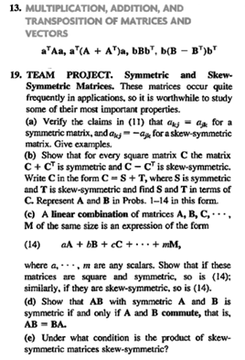
Section 7.3
Problems: 7, 13, 17
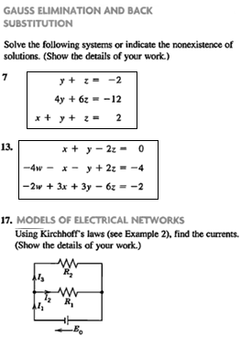
Section 7.4
Problems: 7, 13, 22, 31
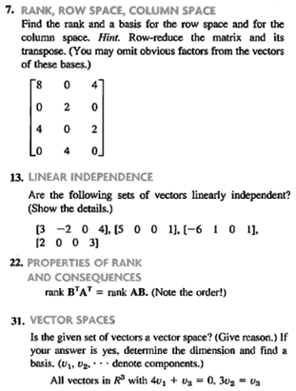
Section 7.7
Problems: 7, 19
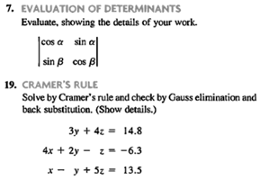

Section 7.8
Problems: 9, 14, 17
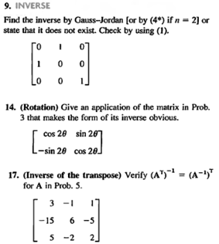
Section 7.9
Problems: 3, 10
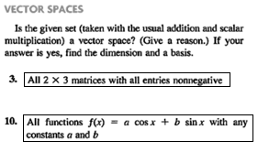

Chapter 8
Section 8.1
Problems: 10, 30
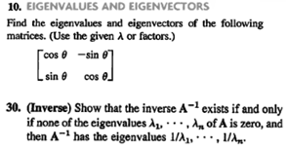
Section 8.2
Problems: 1, 4, 7
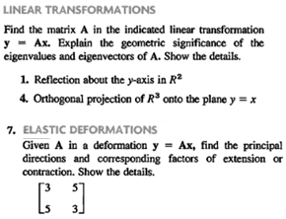
Section 8.3
Problems: 4, 15
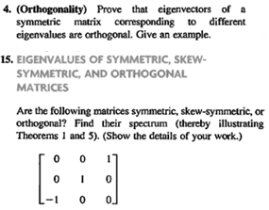
Section 8.4
Problems: 7, 14, 24
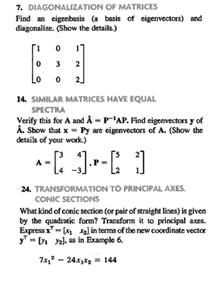

Chapter 11
Section 11.1
Problems: 3, 9, 11, 13, 21, 23, 24
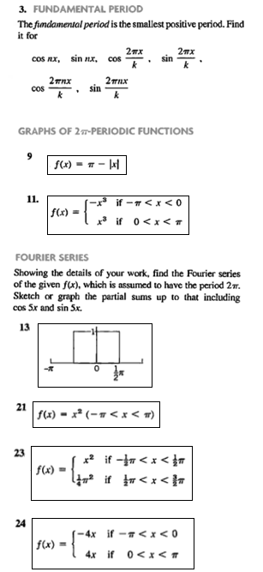

Section 11.2
Problems: 1, 9, 11, 14, 15
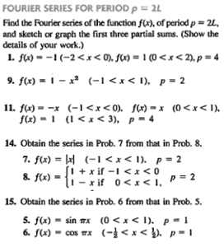
Section 11.3
Problems: 5, 6, 12, 13, 22, 25
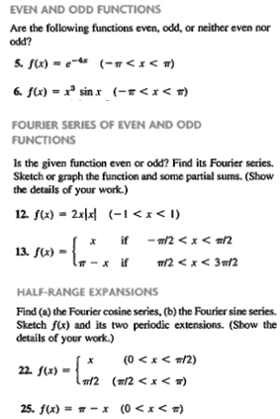
Section 11.5
Problems: 1, 2, 6, 11, 15
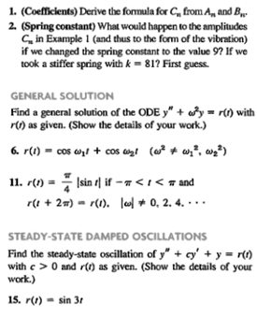
Section 11.6
Problems: 3, 8, 12, 15
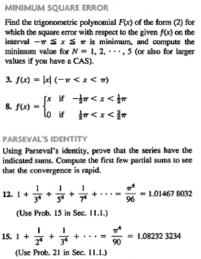
Section 11.7
Problems: 4, 6, 7, 15
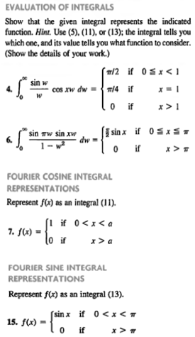
Section 11.8
Problems: 1, 4, 5, 14
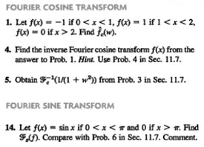

Section 11.9
Problems: 2, 4, 8, 11, 13
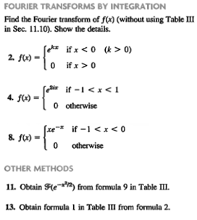
Section 11.10
Problems: 1, 3, 5, 6, 8, 9, 10, 11
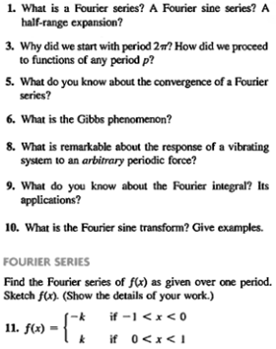

Chapter 12
Section 12.1
Problems: 11, 12, 16, 19, 25
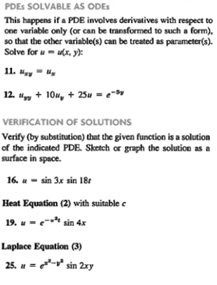
Section 12.3
Problems: 1, 11, 7, 15, 16
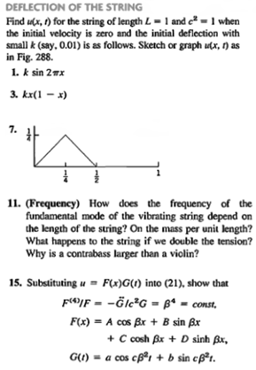
Section 12.5
Problems: 5, 7, 14, 30
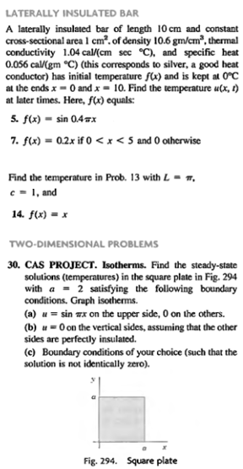
Section 12.6
Problems: 1, 4
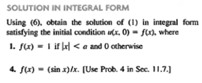

Section 12.8
Problems: 5, 8, 12, 15
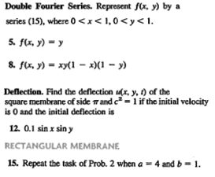
Section 12.9
Problems: 5, 7, 12, 25
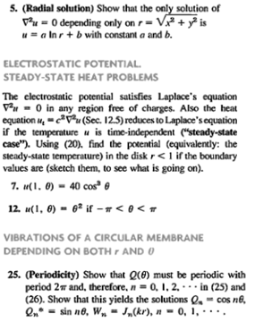

Section 12.10
Problems: 13, 15
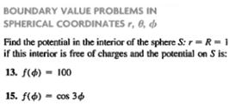
Section 12 Review
Problems: 2, 10
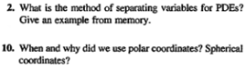

Chapter 13
Section 13.1
Problems: 12, 19
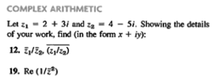
Section 13.2
Problems: 20, 24, 27, 33
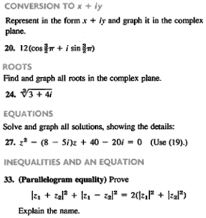

Section 13.3
Problems: 2, 4, 10, 18, 24
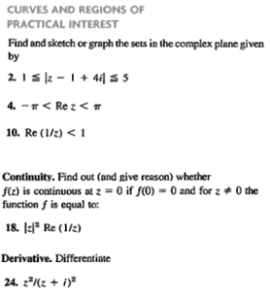
Section 13.4
Problems: 4, 8, 12, 20, 22
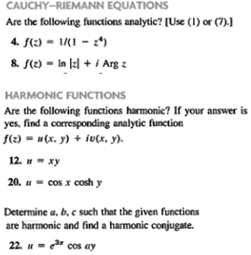

Section 13.5
Problems: 3, 11, 15, 21
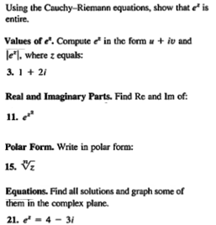
Section 13.6
Problems: 15, 17
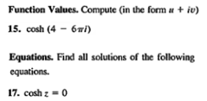
Section 13.7
Problems: 20, 25
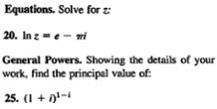

Chapter 14
Section 14.1
Problems: 7, 20, 24, 29
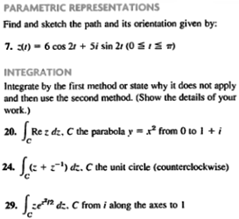
Section 14.2
Problems: 3, 9, 10, 23, 28
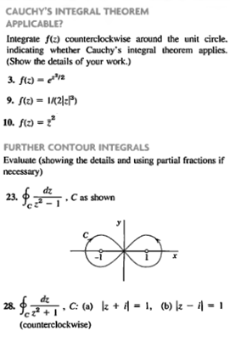
Section 14.3
Problems: 1, 3, 7, 14, 18
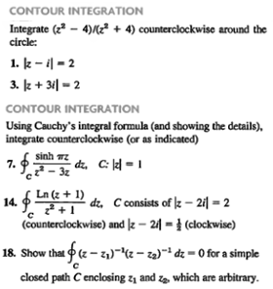
Section 14.4
Problems: 2, 4, 10, 13
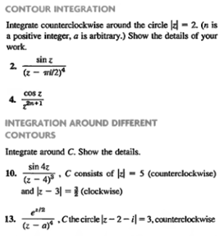

Chapter 15
Section 15.1
Problems: 3, 13, 16, 18, 20
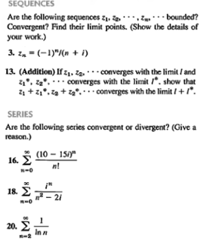
Section 15.2
Problems: 3, 6, 14, 15, 17
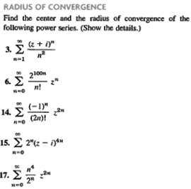

Section 15.3
Problems: 5, 9, 10, 12
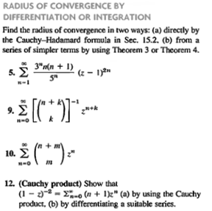
Section 15.4
Problems: 4, 6, 7, 9, 14
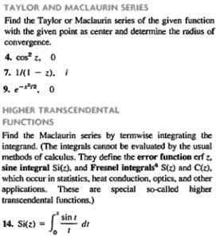

Chapter 16
Section 16.1
Problems: 2, 7, 8, 18, 21
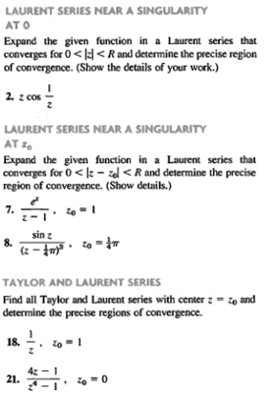
Section 16.2
Problems: 7, 9, 10, 18, 19
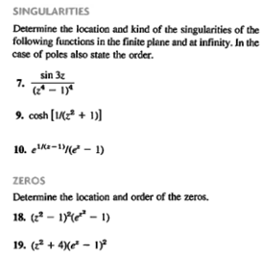
Section 16.3
Problems: 6, 11, 17, 22, 23
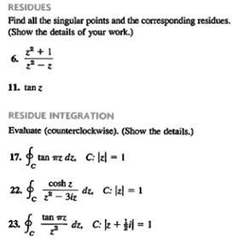
Section 16.4
Problems: 2, 7, 16, 19, 27
