숙제 목록

이하 모두 교과서로 사용된 Foundations of Analog and Digital Electronic Circuits, Anant Agarwal and Jeffrey H. Lang, Morgan Kaufmann 책에서 출제되었음.

Solve the following problems: deadline - October 5
(301-456, teaching assistant: Shinhaeng Kang)
Chap. 2. Exercise 2.6, 2.8 (c)(e), 2.9 Problem 2.2, 2.11
Solve the following problems:
Exercise 3.1, 3.2, 3.11, 3.16, Problem 3.3, 3.8, 3.11, 3.13
Due: October 19th, 2010.
Solve the following questions.
Chap. 4: Exercise 4.4, 4.7, Problems 4.11, 4.12
Chap. 5: Exercise 5.10
Deadline: Oct. 26
Solve the following questions.
(Due: November 23)
Chap. 6
Exericse 6.2, 6.3, 6.4, Problems 6.2, 6.7
Chap. 7
Exercise 7.6, 7.9, 7.10, Problems 7.2, 7.3, 7.17
Solve the following problems
Exercise 9.6,
Problem 9.3

숙제 답안

Chap 2 Solution
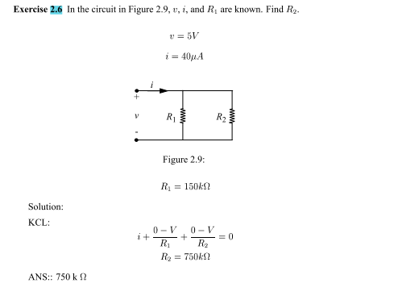

Exercise 2.8
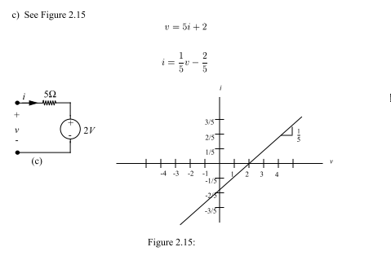
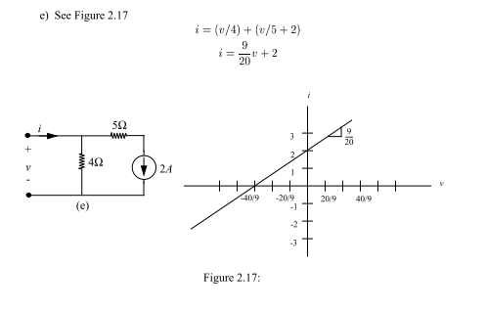

Exercise 2.9
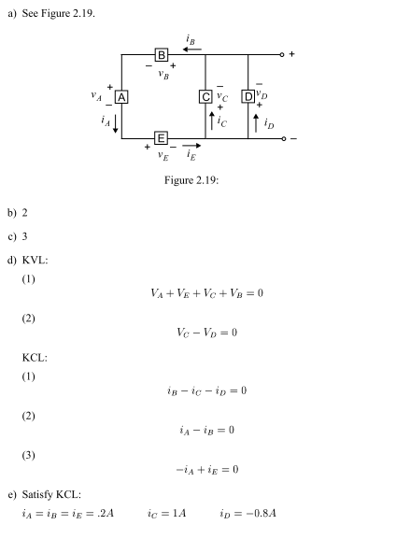
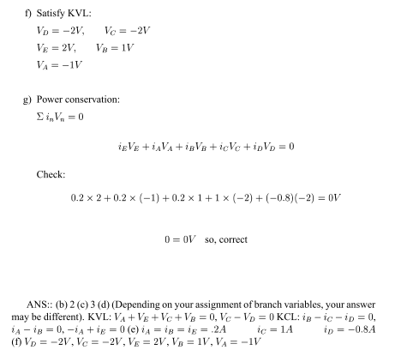
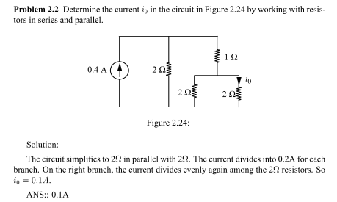
Problem 2.11
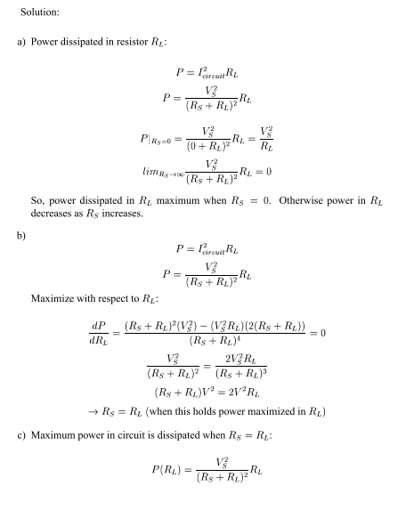
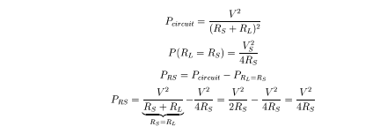

Exercise 3.1
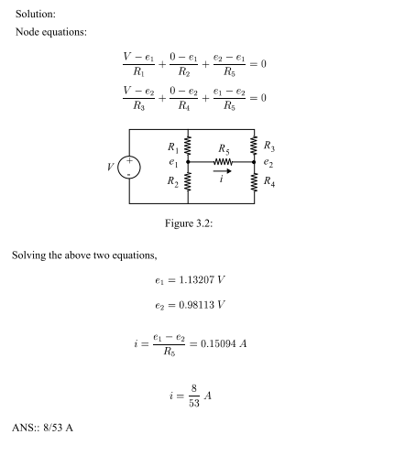
Exercise 3.2
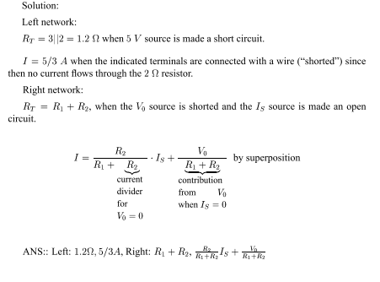
Exercise 3.11
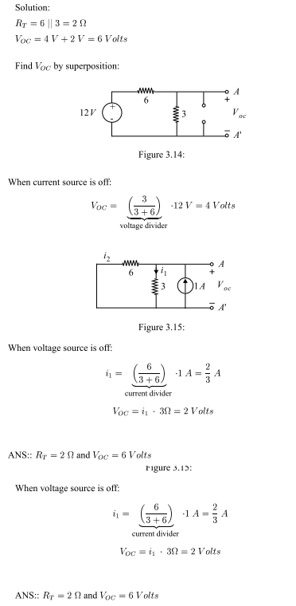

Exercise 3.16
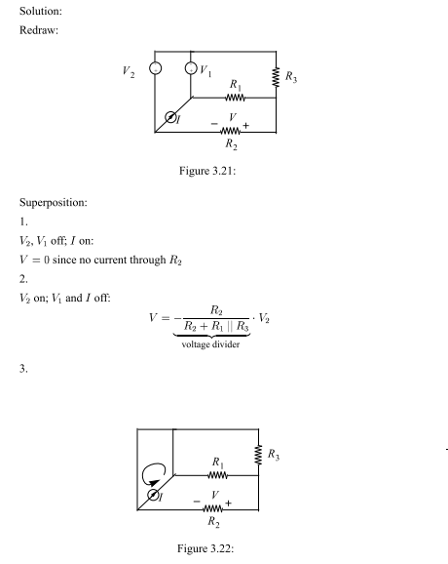
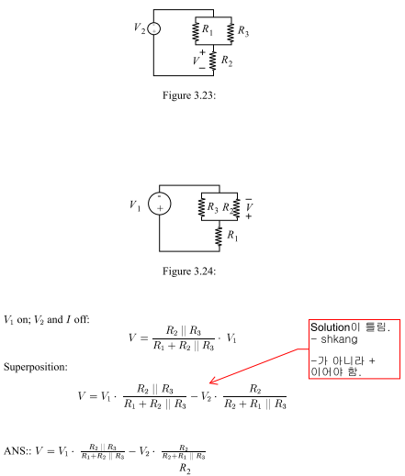

Problem 3.3
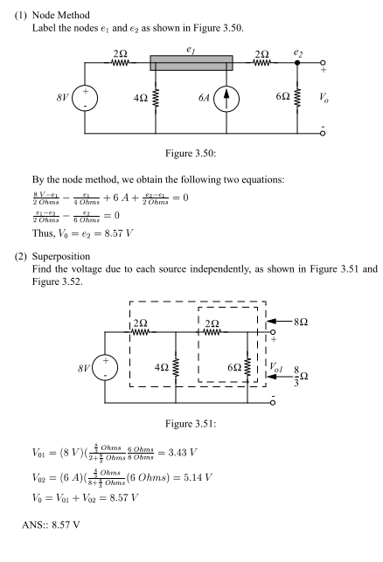
Problem 3.8
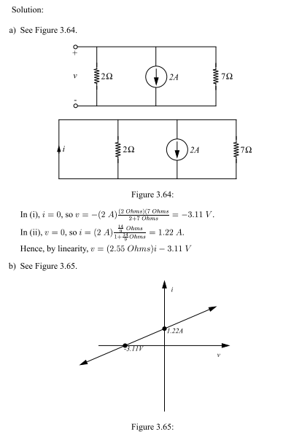
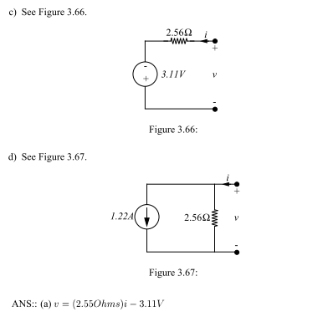
Problem 3.11
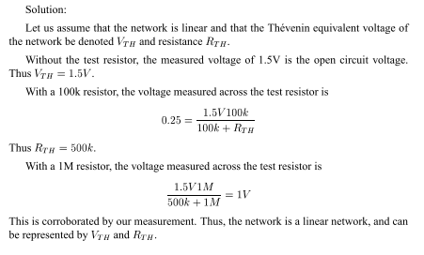
Problem 3.13
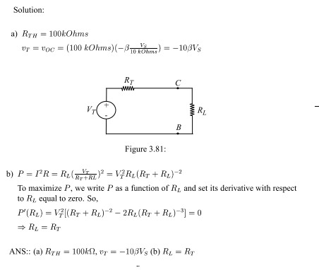

Exercise 4.4
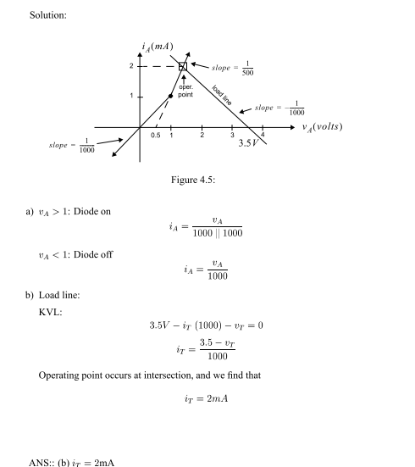

Exercise 4.7
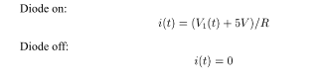
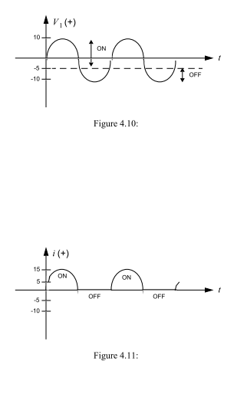

Problem 4.11
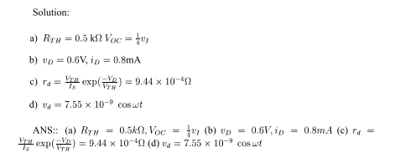

Problem 4.12
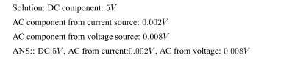

Exercise 5.10
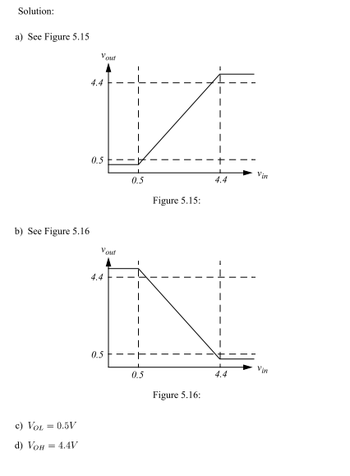
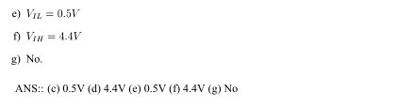

Exercise 6.2
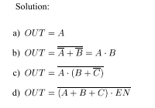
Exercise 6.3
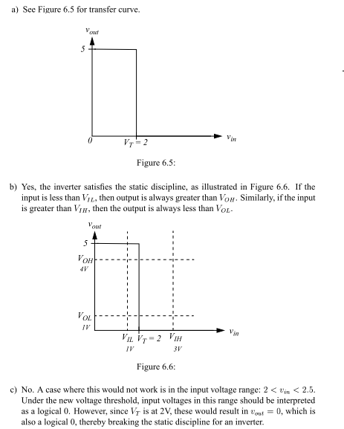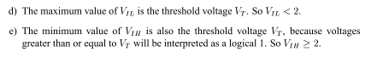
Exercise 6.4

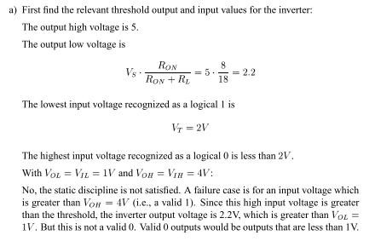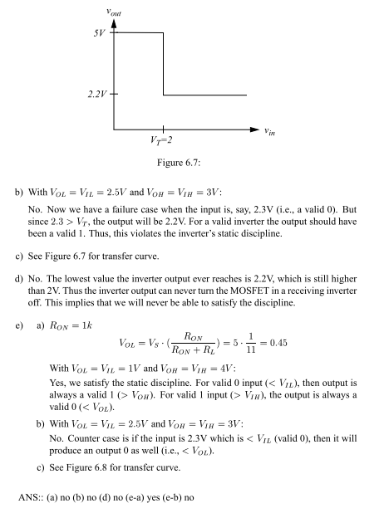

Problem 6.2
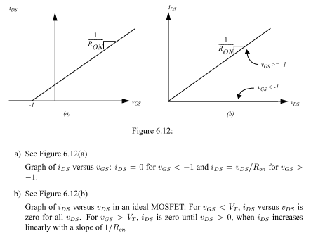

Problem 6.7
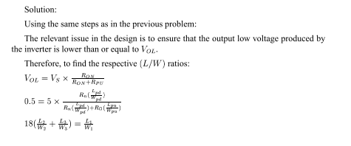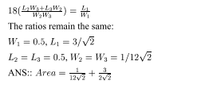

Exercise 7.6

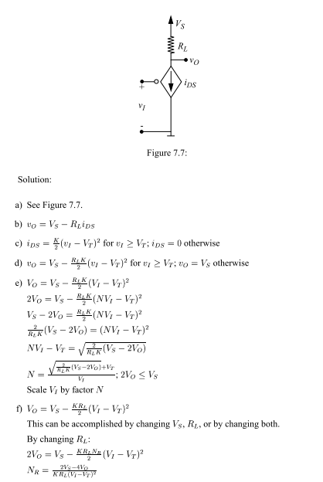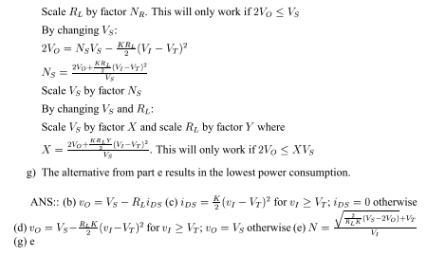

Exercise 7.9

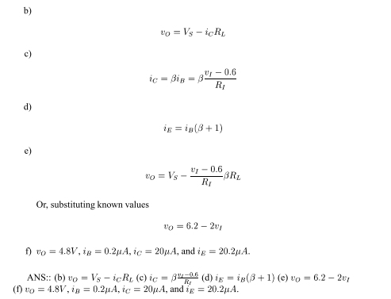

Exercise 7.10

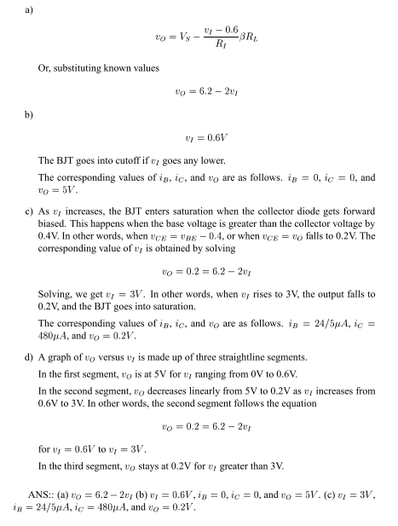

Problem 7.2

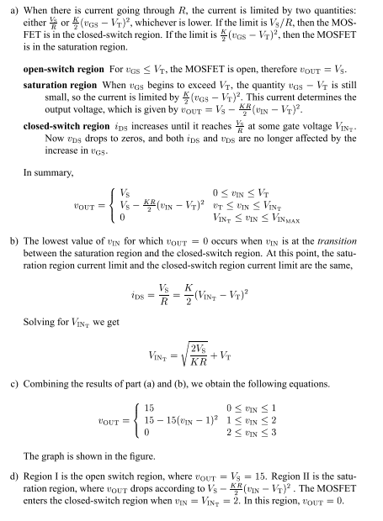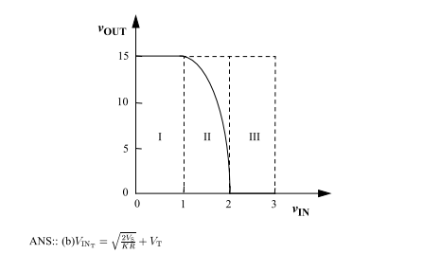

Problem 7.3

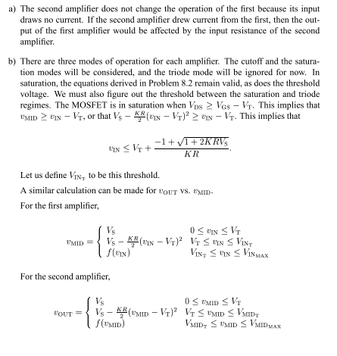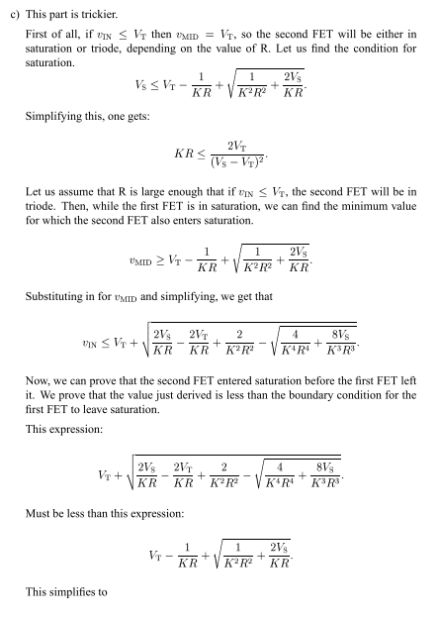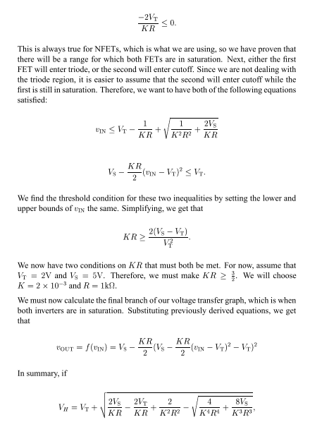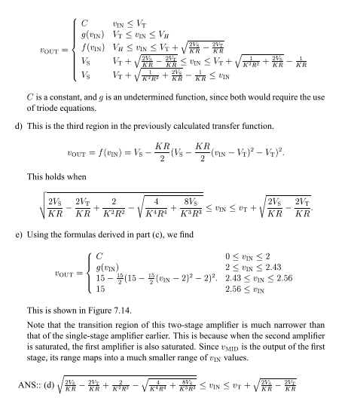

Problem 7.17

