447.327 Theory of Reinforced Concrete and Lab. I
Spring 2008
Midterm Exam April 24, 2008
(Closed Textbook & Note) Instructor: JAE-YEOL CHO

Problem 1. O/X quizzes to test basic knowledge about CONCRETE (each 2pts.)
(total 16 pts.) True False
- Mortar consists of water, cement, and aggregates. _____ _____
- Compressive strength is more affected by W/C than flexural strength. _____ _____
- If every average of any three consecutive strength test equals or exceed f_{ck} , quality control would be satisfactory. _____ _____
- For normal concrete, at least 0.25 of W/C is required. _____ _____
- The compressive strength of cylinder is higher than that of cube. _____ _____
- Elasticity modulus of normal weight concrete, f_{ck} =27 MPa, is 25,500MPa. _____ _____
- The higher strengths of concrete and steel show the larger strains at peak. _____ _____
- Mix proportion is expressed by ingredients quantity of 1 ton concrete. _____ _____

Problem 2. Give brief answers to show your LOVE for this class (each 3pts.)
(total 24 pts.)
- Explain the types of Portland cement.
- Explain the requisites of mix design.
- Explain “bleeding” and “segregation”.
- Explain the time dependent characteristics of concrete.
- Why do we think concrete and steel reinforcement are the best matched couple? (three reasons)
- Why in practice reinforcement ratio should be smaller that the balanced reinforcement ratio? (at least three reasons)
- Explain the basic assumptions in reinforced concrete design
- Why does Code specify the min. number of bars in a single layer?

Problem 3. Briefly discuss to show your UNDERSTANDING. (each 4pts.)
(total 20 pts.)
- Discuss the behavior of RC beam using moment-curvature curve.
- Draw the stress-strain curve of steel and discuss it.
- Explain the PCA test method to get a true picture of the stress-strain relationship for concrete during loading to failure. (illustrated in Hognestad’s paper)
- Explain the necessity of low limitation of reinforcement ratio.

- Discuss this graph.
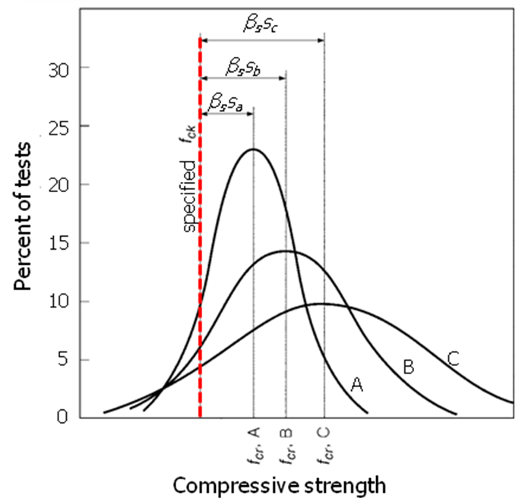

Problem 4. Analysis of Doubly Reinforced Rectangular Beam (40pts.)
A rectangular beam with width b = 610 mm, total depth h = 355 mm, and effective depth d = 290 mm is constructed using material with f_{ck} = 27 MPa and f_{y} = 400 MPa. Tensile reinforcement consists of two No. 35 bars plus three No. 32 bars in one row. Compression steel consisting of two No. 32 bars are placed at distance 65 mm from the top surface of beam. Calculate the nominal and design strength of the beam. (Nominal cross section areas of No. 32 and No. 35 are 794.2 mm² and 956.6 mm², respectively.)

