Organic Chemistry II. 2008 2nd Exam Student ID# Name

1. (14 points) (a) (6 points) The heat hydrogenation of cyclooctene to cyclooctane is -23.3 kcal/mol. The heat hydrogenation of cyclooctateteraene to cyclooctane is -109.3 kcal/mol. For comparison the heat hydrogenations of cyclohexene to cyclohexane and benzene to to cyclohexane are -28.6 kcal/mole and -49.8 kcal/mol, respectively. Use these data to calculate an empirical resonance energy values for cyclooctateteraene and benzene. Discuss the stability of cyclooctateteraene and benzene using the empirical resonance energy values.

- 23.3 kcal/mol X 4 + 109.3 kcal/mol = 16.1 kcal/mol : destabilization (cyclooctatetraene)

-28.6 kcal/mol X 3 + 49.8 kcal/mol = -36.0 kcal/mol : stabilization (benzene)

Benzene : Resonance stabilization, energy 안정화

Cyclooctatetraene : destabilization, energy 불안정화

➔ 각각 1.5 점
식 맞고 답 틀리면 -1
부호 틀리면 -1 (위의 답의 부호가 반대이면 맞은 걸로 처리함)

(b) (8 points) Discuss whether cyclooctateteraene and benzene are aromatic, nonaromatic or antiaromatic using molecular orbital model and Hückel’s rule.

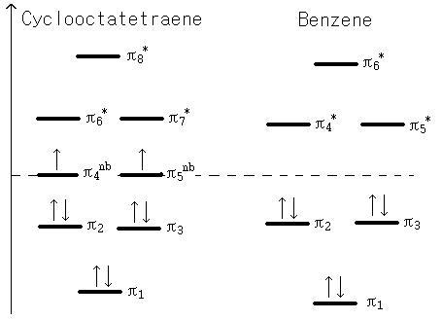
Benzene : cyclic, fully conjugated, planar, 6 pi electrons(1점) : Aromatic(1점)
Cyclooctatetraene : non planar(1점) : non-aromatic(1점)

➔ molecular orbital model 각각 2점

2. (7 points) Which π bond of phenanthrene would you expect to have the greatest reactivity towards Br₂ in CH₂Cl₂?. Explain why.

답 : 3번 bond가 가장 reactivity가 가장 높음. (2점)
이유 (5점)
1. 3번 위치에 bromination 되면, 바깥쪽에 있는 aromatic ring이 유지 되는데 이는 aromatic ring은 naphthalene stabilization 되어 있기 때문에 3번이 가장 reactive함.
2. resonance를 그리게 되면, 위에 같이 5개가 그려지는데, 3번 위치의 double bond 특성이 가장 많아진다. ( 각resonance당 1점씩)
3. bromination 될 때, intermediate의 resonance의 수가 많은 쪽으로 반응이 많이 일어 난다고 할 때, intermediate의 resonance로 알 수 있음 (resonance를 그려야함.)

3가지 이유중 한가지만 선택해서 써도 무관.

3. (8 points) Bipheny , C₆H₅- C₆H₅ is reacted with one equivalent of nitric acid in the presence of sulfuric acid. Predict major products (could be more than one) and explain why.

Major product :

Ortho/para 위치에 substitution이 일어난다. (Phenyl : Ortho para director)
Ortho 위치에도 product가 생기지만 이는 steric effect로 인해 para보다 상대적으로 적음.

The phenyl group can stabilize a positive charge on the adjacent carbon by resonance.
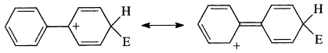

답이 맞았을 경우 (5점)
이유 : phenyl에 의한 stabilize를 resonance로 그려야 함.(2점)
resonance란 단어가 들어 가 있고 resonance를 그리지 않았을 때는 1점
Major product를 그릴 때 para와 ortho 구분시 steric effect란 단어가 들어가지 않았을 경우 (-2점)

4. (15 points) Which one of each of the following pairs is more reactive toward electrophilic aromatic substitution reaction? Give brief reason for your answer.
(a) acetanilide () or benzene
Acetanilide,
NHC(O)CH₃ : electron donating (resonance donating) group & stabilizes the transition state
(b) bromobenzene or toluene

Toluene,
-CH₃ : electron donating group

(c) p-xylene (p-dimethyl benzene) or p-toluic acid (p-methylbenzoic acid)

p-xylene,
-CH₃ : electron donating group (cf. –CO₂H : electron withdrawing group)

(d) m-dinitrobenzene or m-nitrotoluene

m-nitrotoluene,
-CH₃ : electron donating group (cf. –NO₂ : electron withdrawing group)

(e) chlorobenzene or m-dichlorobenzene

Chlorobenzene,
-Cl : only one electron withdrawing group

5. (10 points) Draw the major organic products of the following reactions.
(a) 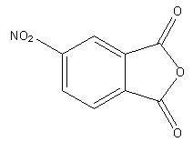 and 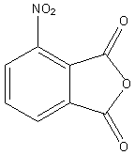
(steric effect 로 인해 첫 번째 구조가 약간 많을 수 있다.)

우선 2가지 produt를 모두 썼을 경우 (5점)
첫번째 compound만을 썼을 경우에도 major product를 쓰라고 하였기 때문에(5점)
그러나 두번째 compound 만을 그렸을 경우 (2.5점)
(b) 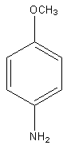 and 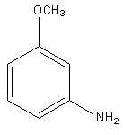 (50:50)

각 compound 당 2.5점씩 (50 :50 mixture로 나오기 때문에)
또한 이 반응은 elimination-addition 이기 때문에, 반응 mechanism을 몰랐다고 생각될 경우 감점 1점

6. (16 points) Devise a synthesis that will accomplish the following transformations
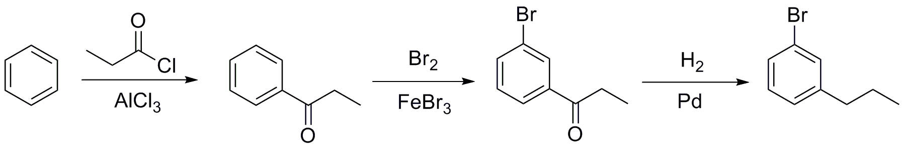
(a)

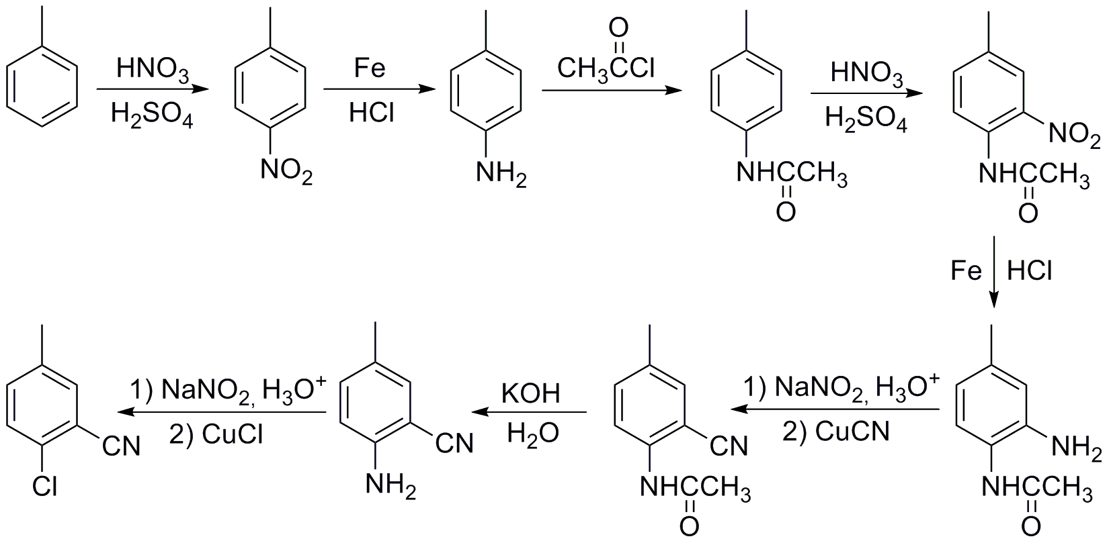
(b)

➔ 경미한 오류(-1)
짝을 이루는 reagents를 잘못 사용하면 (-2)
반응이 진행 될 수 없는 경우에는 부분점수 없음

7. (10 points) Show all of the steps in the mechanism for the following reaction. Explain why the acetyl group accelerates the reaction.

➔ main reaction (3점)
3가지 resonance 구조(7점) → 하나가 틀리면 (-2)
구조는 맞지만 전자를 잘못 움직이면 (-2)
8. (20 points) Determine the structure based on the spectral data provided on the following page. Try to assign as many peaks in the spectra as possible for the full credit and you should show your peak assignments directly on top of the spectra. Write down the proposed structure and the name of the compound, and your reasoning process on this page.
⑤
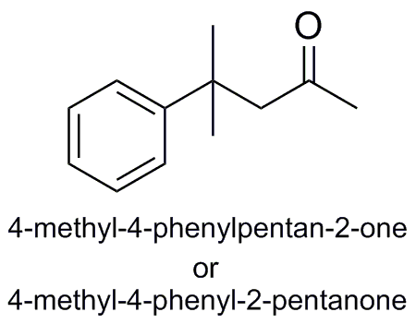
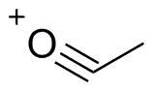
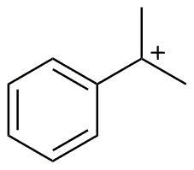
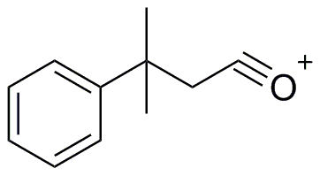
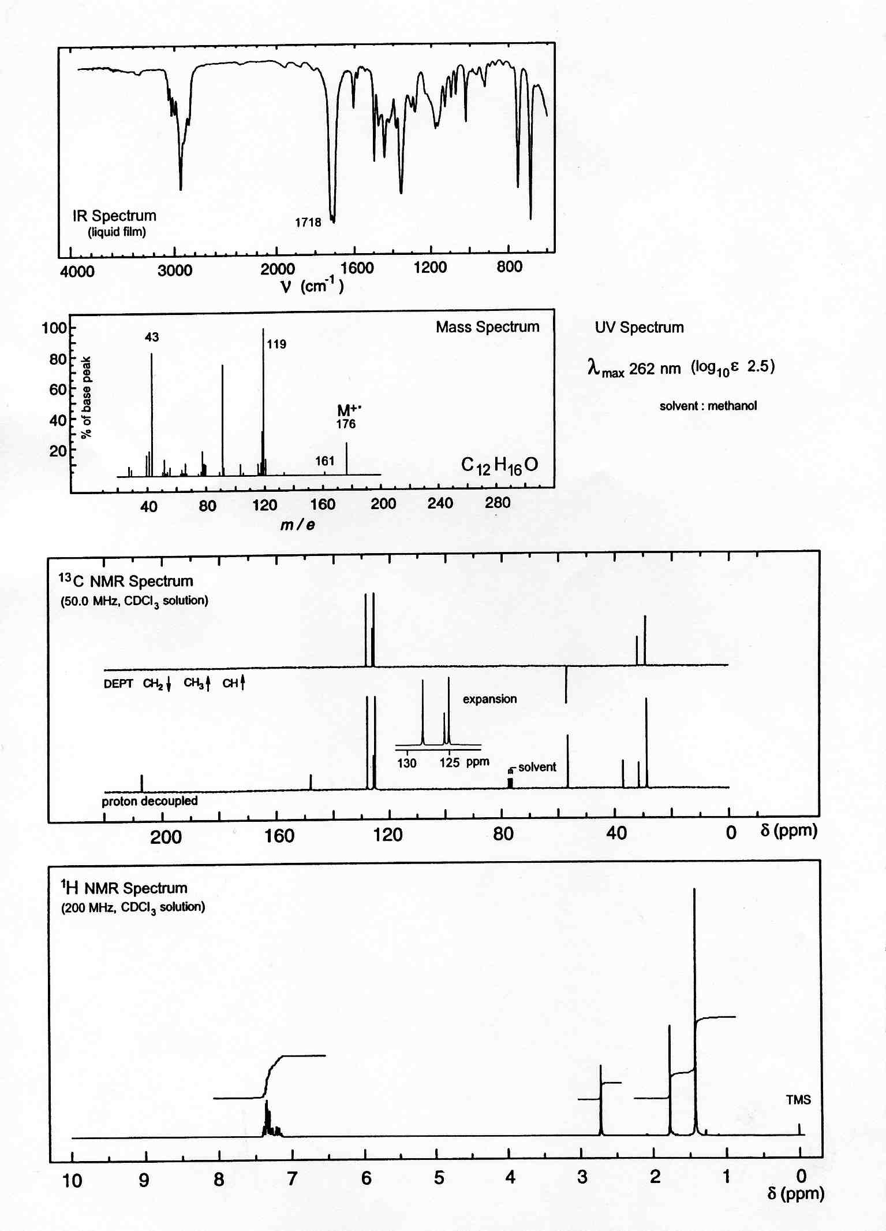
①
②
③
④
⑥
⑦
⑧
⑨
Sp3 C-H
C=O
①
②
③
④
⑤
⑥
⑦
⑧
⑨
⑤
①
③
⑦
⑧
⑨
Carbonyl group or benzene ring
DU=(12x2+2-16)/2=5
Benzene
ring

➔ compound (8점), name(2점)
IR (1점)
Mass(3점) → 하나 당 1점씩 감점
¹³C-NMR(3점) → 이유 안 쓰면 (-1)
¹H-NMR(3점) → 이유 안 쓰면 (-1)

