**1. (30 points)** A small ball swings in a horizontal circle at the end of a cord of length *l1*, which forms an angle *θ1* with the vertical. The cord is then slowly drawn through the support at O until the length of the free end is *l2*.

a) Derive a relation among *l1*, *l2*, *θ1* and *θ2* (20 points)

b) If the ball is set in motion so that initially *l1* = 2 ft and *θ1* = 40, determine the angle *θ2* when *l2* = 1.5 ft (10 points)



**2.** **(30 points)** A 5-kg uniform square plate is supported by two identical 1.5-kg uniform slender rods AD and BE. It is held in the position shown by rope CF. Determine, immediately after CF has been cut,

a) The acceleration of the plate (15 points)

b) The force exerted on the plate at point B (15 points)

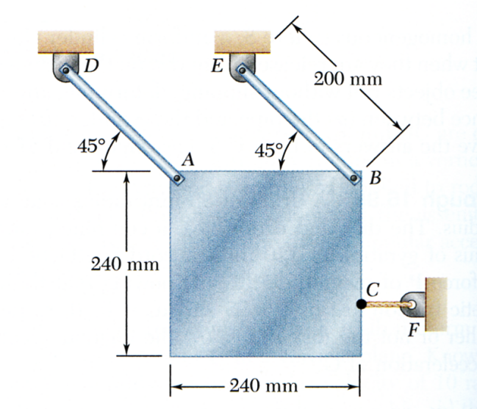

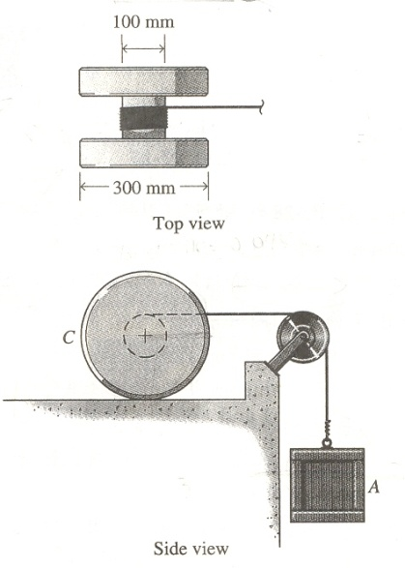**3.** **(40 points)** The 10-kg spool c has a centroidal radius of gyration of 75 mm. A cord is attached to the center of the spool, passes over a small frictionless pulley, and is attached to a 25 kg crate A. If the system is released from rest and the spool rolls without slipping, after the crate has dropped 2 m, determine.

1. The speed VC of the spool (20 points)
2. The angular velocity $ω_{c}$ of the spool (10 points)
3. The speed VA of the crate (10 points)