Final Exam: Deformation of Concrete, Dec. 9, 2010

1. Find the curvature at t0 and at later time t and draw sketches of the variation of the curvature over the span of simply supported beam. What is the deflection at mid-span at t? The reinforced concrete simple beam of the constant cross section shown in the figure has steel ratios,  % and  %. The following data are given; *E*s=200GPA; *E*c(t0)=30.0GPa, fct=2.5MPa; ;  for calculation of instantaneous curvature and 0.5 for long term curvature; creep coefficient ; aging coefficient, ; free shrinkage, 



1. Find the stress distribution at supports B and C of the continuous bridge shown in the figure due to a rise of temperature whose distribution varies over the depth of the cross section as suggested by Priestley. Consider E= 30.0 GPa and 



1. For the following slab, find the long-term deflection at the center of typical interior panel for given the total moment with the slab thickness 200 mm. The compressive strength of concrete is 30 MPa. Use the elasticity of modulus as 4700 sqrt (f’c). The moulus of rupture is 0.7 sqrt (f’c). The yield strength of steel reinforcement is 300MPa and the elasticity of modulus of steel is 200 GPa. The creep coefficient ; aging coefficient .

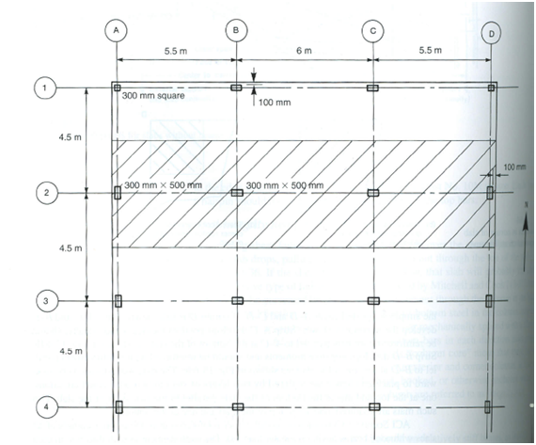

S

N

Moments in East-west strips

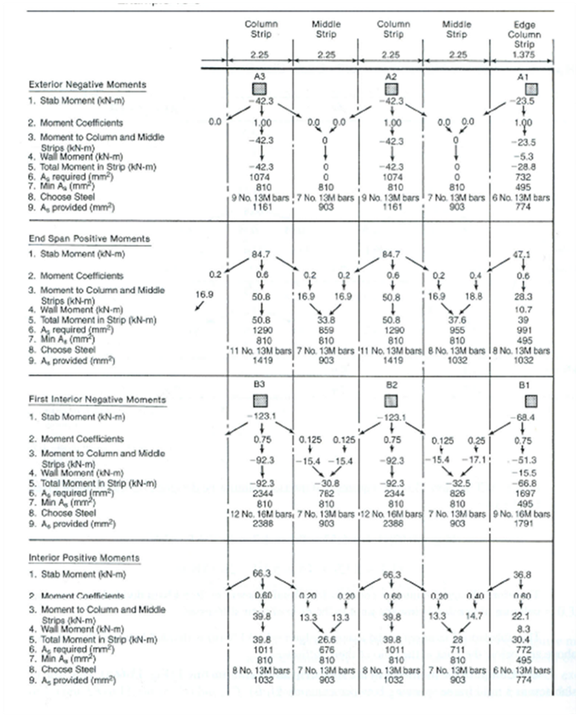

Moments in South- north strips

