1. (총 33점) All bars of the planar truss shown Fig. 1 are of cross-sectional area, **A**, and modulus **E**. Joints **C** and **D** are pinned to the vertical wall. (1) (10점) Use the unit load method to find the vertical and the horizontal deflections of joint **A**, and (2) (10점) the rotation of bar **AB**.

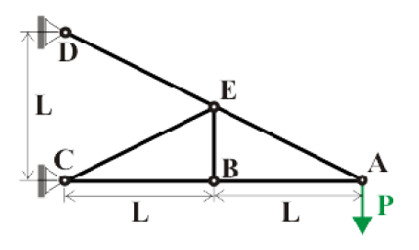

Fig. Planar truss with tip load

1. A cantilevered beam of length **L**, and bending stiffness, **H**, carries a tip load **P**, as shown in Fig. 2. At mid-span, the beam is braced by a bar, **BM**, of stiffness **S**=**EA**, oriented at an angle ***Ф*** = 60°. (1) Find the magnitude and location of the maximum bending moment in the beam. The effect of the axial load in portion **RM** of the beam is negligible because the beam’s axial stiffness is very large. (2) Find the transverse deflection at point **T**.

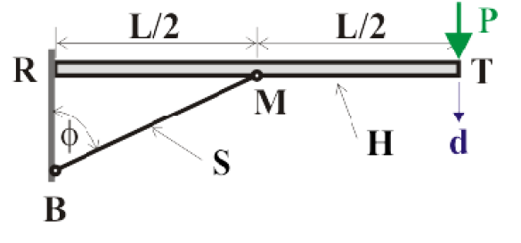

Fig. Cantilever beam with supporting truss

1. (33점) A cantilevered beam of L is subjected to a uniform loading distribution, ***p0***, as depicted in Fig 3. An additional support is located at the beam’s tip, and a rotational spring of stiffness constant **k** acts at the same point. (1) (10점) Use the least work principle to determine the tip support reaction forces. (2) (10점) Find the bending moment distribution in the beam.

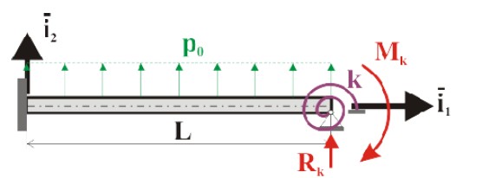

Fig. Cantilevered beam with tip rotational spring

1. (34점) Consider the uniform, semi-circular beam with a rigid arm attached at its tip, as shown in Fig. 4. The beam is made of a linearly elastic material and the radius of its centerline is **R**. A load of magnitude P acts at the tip of the rigid arm in the plane of the beam, but its orientation in this plane is otherwise arbitrary. Show that: (1) (10점) The displacement, ***Δ***, of point **O** is in the direction of the applied load for an arbitrary orientation of **P**, and (2) (10점) the spring constant **k** = **P**/***Δ*** is independent of the orientation of the load P. Hint : At first, examine the behavior of the beam under a horizontal force, **H**. Next, turn to a vertical force, **V**. The behavior of the system under a general loading is then oriented by invoking the principle of superposition for a linear system. You should assume that only deflections will contribute to the strain energy in the beam, *i.e.*, ignore axial deformation.

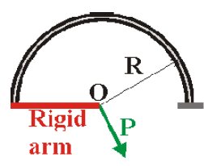

Fig. 4 Semi-circular beam with a rigid arm

SOL

1. dA = (8+5 $√5)PL/EA$

|  |  |  |  |  |
| --- | --- | --- | --- | --- |
| Rod | L/EA | F | $$\hat{F}$$ | $$Δ$$ |
| AB | L/EA | -2P | -2 | 4PL/EA |
| AE | $√5$ L/2EA | $$√5P$$ | $$√5$$ | 5 $√5$ PL/2EA |
| BC | L/EA | -2P | -2 | 4PL/EA |
| BE | L/2EA | 0 | 0 | 0 |
| CE | $√5$ L/2EA | 0 | 0 | 0 |
| DE | $√5$ L/2EA | $$√5P$$ | $$√5$$ | 5 $√5$ PL/2EA |

ФAB = (9/2 + +15 $√5$/4)P/EA rad

|  |  |  |  |  |
| --- | --- | --- | --- | --- |
| Rod | L/EA | F | $$\hat{F}$$ | $$Δ$$ |
| AB | L/EA | -2P | -2 | 4PL/EA |
| AE | $√5$ L/2EA | $$√5P$$ | $$√5$$ | 5 $√5$ PL/2EA |
| BC | L/EA | -2P | -2 | 4PL/EA |
| BE | L/2EA | -1P | -1 | PL/2EA |
| CE | $√5$ L/2EA | $$\sqrt{5}P/2$$ | $√5$/2 | 5 $√5$ PL/8EA |
| DE | $√5$ L/2EA | $$\sqrt{5}P/2$$ | $√5$/2 | 5 $√5$ PL/8EA |

2.

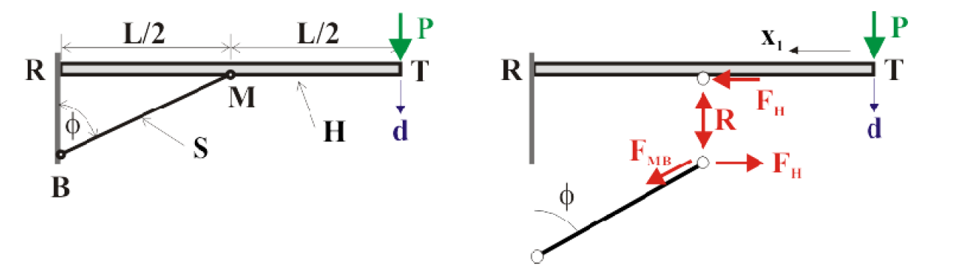



Cut system with real loads(subscript starts with 0) :



Cut system with unit loads(R=1, hat & subscript starts with 0) :



(segment TM)



(segment RM)



Find R



Extreme bending moments at A and C



(2)

for unit load at tip,

Segment TM



Segment MR



3.

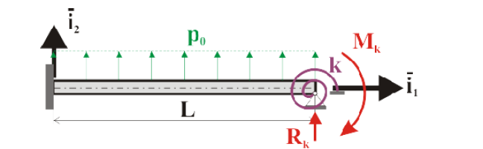

Bending moment due to load



Strain energy



Least energy principle



1. Using Mk, Rk



4.

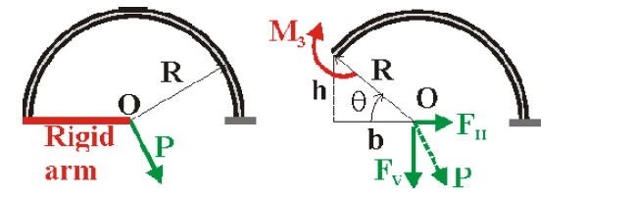

(1)



Deflection due to FH alone



Deflection due to FV alone



(2) 