Cryogenic (Mid-Term Exam.) Solution

1. In Fig. 2.2. When the temperature is lowered, the yield strength of most engineering materials increases. As the temperature is lowered, the atoms of the material vibrate less vigorously. Because of the decreased thermal agitation of the atoms, a larger applied stress is required to tear dislocations from their atmosphere of alloying atoms. From this line of reasoning, it should be expected that the yield strength for alloys would increase as the temperature is decreased.
2. (a) Joule-Thomson coefficient 

Using the calculus the following can be derived by chain rule,



Rearranging The terms,



Also, the entropy can be defined as the function of temperature and pressure.



Using the calculus, the following can be derived.

, ----(1)

The definition of specific heat under constant pressure : 

From the Maxwell’s equation : 

From above, equation (1) can be shown that

---(2)

From basic thermodynamics, it can be shown that ----(3)

From equation (2), (3), it can be derived that

----(4)

Also, the enthalpy can be defined as the function of temperature and pressure



Using the calculus, the following can be derived

----(5)

Comparison (4), (5), we can obtain the following



From given virial equation of state,  the following can be derived by partial differentiation.



Arranging above equation, the following can be derived



Finally, calculating the Joule-Thomson coefficient





the isentropic expansion coefficient 

Using the calculus the following can be derived by chain rule,



Rearranging The terms,



Also, the entropy can be defined as the function of temperature and pressure.



Using the calculus, the following can be derived.

, ----(1)

The definition of specific heat under constant pressure : 

From the Maxwell’s equation : 

From basic thermodynamics, it can be shown that ----(3)



From given virial equation of state,  the following can be derived by partial differentiation.



Arranging above equation, the following can be derived



Finally, calculating the isentropic expansion coefficient



(b) From given diagram, the final temperature is approximately 282K.

For nitrogen, gas constant and specific heat under constant pressure is given the following.

, 

Solve with (a) equation.

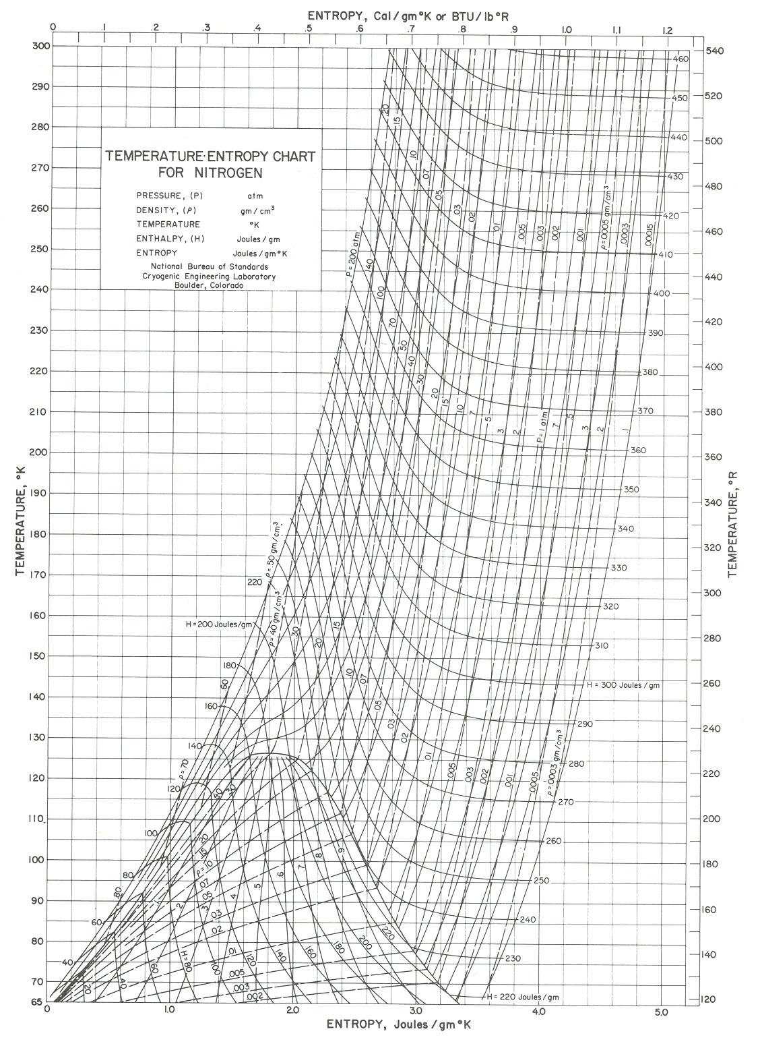

1. (a)

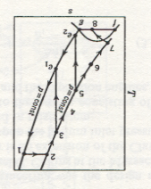

(b)

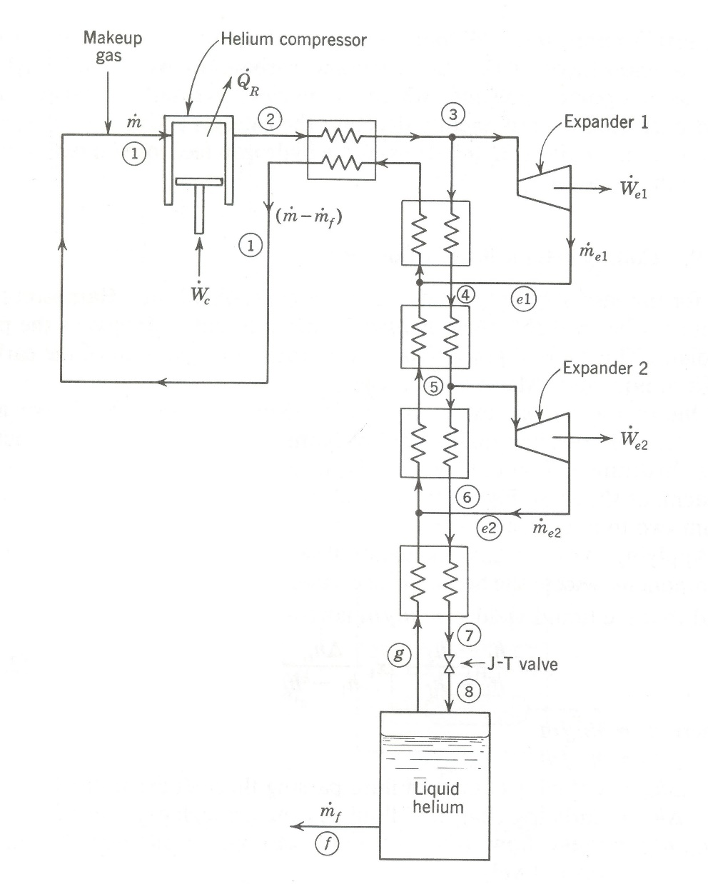

Define the control volume shown above figure. Applying the First law for steady flow to the control volume,

------(1)

If we define the fraction of the total flow that passes through each expander as ,  or

, 

Then the liquid yield may be obtained from equation (1) as



(c) From temperature-entropy chart for helium 4, , , , , , , .



(d) The compressor efficiency has no effect on the liquid yield, as long as enough energy is available to provide the required pressure levels for the cycle. However the compressor work requirements are directly related to the compressor efficiency.

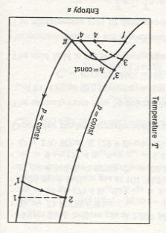

On the other hand, the efficiency of the expander affects both the liquid yield and the work requirements. The adiabatic efficiency of the expander affects the enthalpy drop across the expander, as shown in above figure, the actual enthalpy change across the expander adiabatic efficiency,

  
 For a Collins helium-liquefaction system with an expander having an adiabatic efficiency less than unity, the liquid yield is given by





(e) The work required per unit mass is calculated by the following equation.



From T-s diagram,, 



(f) The compressor efficiency has no effect on the liquid yield, as long as enough energy is available to provide the required pressure levels for the cycle. However the compressor work requirements are directly related to the compressor efficiency. For compressor efficiencies less than unity, the aftercooler would be required to remove more energy than for the 100 percent efficient compressor, but the same values of  and  could be attained for various values of compressor efficiency. The compressor overall efficiency affects the compressor work per unit mass liquefied, as given by



The above equation and the equation at (d) []

The net work requirement per unit mass compressed for the Collins helium-liquefaction system is



(g)

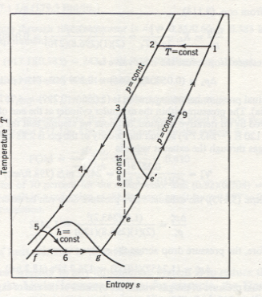

Suppose that the exchanger has an effectiveness  less than unity. The cold stream will not leave the exchanger at condition 1 but at a lower temperature given by state point 1’(see above figure). The heat-exchanger effectiveness is given by



We find that the liquid yield is given by



Solving for , results in



At the low pressures involved for the return stream, the gas acts almost as an ideal gas. Therefore, the additional work requirement due to an exchanger effectiveness less than unity is given by



(h) The effect of heat transfer is to reduce the liquid yield. The First law applied to a system with heat transfer from the surroundings results in



Solving for the liquid yield,



(i) Although we can get more liquid yield using precooling, this method need more precooling work. But using more expander can increase liquid yield while reducing the work required.

(j) The maximum inversion temperature for helium is below ambient temperature.

1. Superconductivity is the simultaneous disappearance of all electric resistance and the appearance of perfect diamagnetism. In the absence of a magnetic field, many elements, alloys, and compounds become superconducting at a fairly well-defined temperature, called the transition temperature in zero field.

There are several properties that change either abruptly or gradually when a material makes the transition from the normal to the superconducting state.

1. Specific hear. The specific heat increases abruptly when a material becomes superconducting.
2. Thermoelectric effects. All the thermoelectric effects (Peltier, Thomson, and Seebeck effects) vanish when a material becomes superconducting. A superconducting thermocouple would not work at all.
3. Thermal conductivity. In the presence of a magnetic field, the thermal conductivity of a pure metal decreases abruptly when the metal becomes superconducting, although for some alloys. The opposite is true.
4. Electric resistance. For Type 1 superconductors the decrease of resistance to zero is quite abrupt; however, for Type 2 superconductors the change is sometime spread over a temperature range as large as 1K.
5. Magnetic permeability. The magnetic permeability suddenly decreases to zero for Type 1 superconductors (the Meissner effect); however for Type 2 superconductors the Meissner effect is in complete for magnetic fields greater than the lower critical field.