Cryogenics (Final Exam.)
M2794.008500 Dec. 14, 2015

1. Calculate the number of theoretical plates in the rectification column for nitrogen-oxygen mixture which meets the following conditions.
(1) The composition of the feed is 60:40 for nitrogen (molecular mass=28) and oxygen (molecular mass=32).
(2) The feed flow rate is 100 mole/s in the saturated liquid state.
(3) Top product should have the nitrogen concentration of 95%.
(4) The bottom product should have 95% of oxygen.
(5) The top product flow rate is 30 mole/s.
(6) The pressure in the rectification column is 100 kPa.
(7) The heat addition in the boiler is 500 kW.
Table 1 Distribution coefficient function ln(Kp/p_{o}). (p_{o}=101.3 kPa, 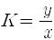)
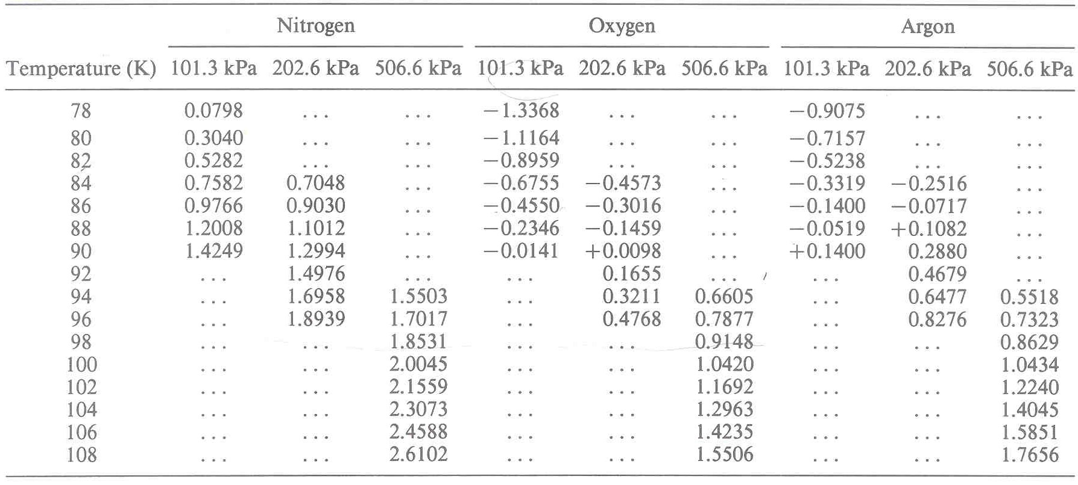
Table 2 Enthalpy of nitrogen-oxygen mixtures. h = enthalpy of the saturated liquid at the bubble point; H = enthalpy of the saturated vapor at the dew point
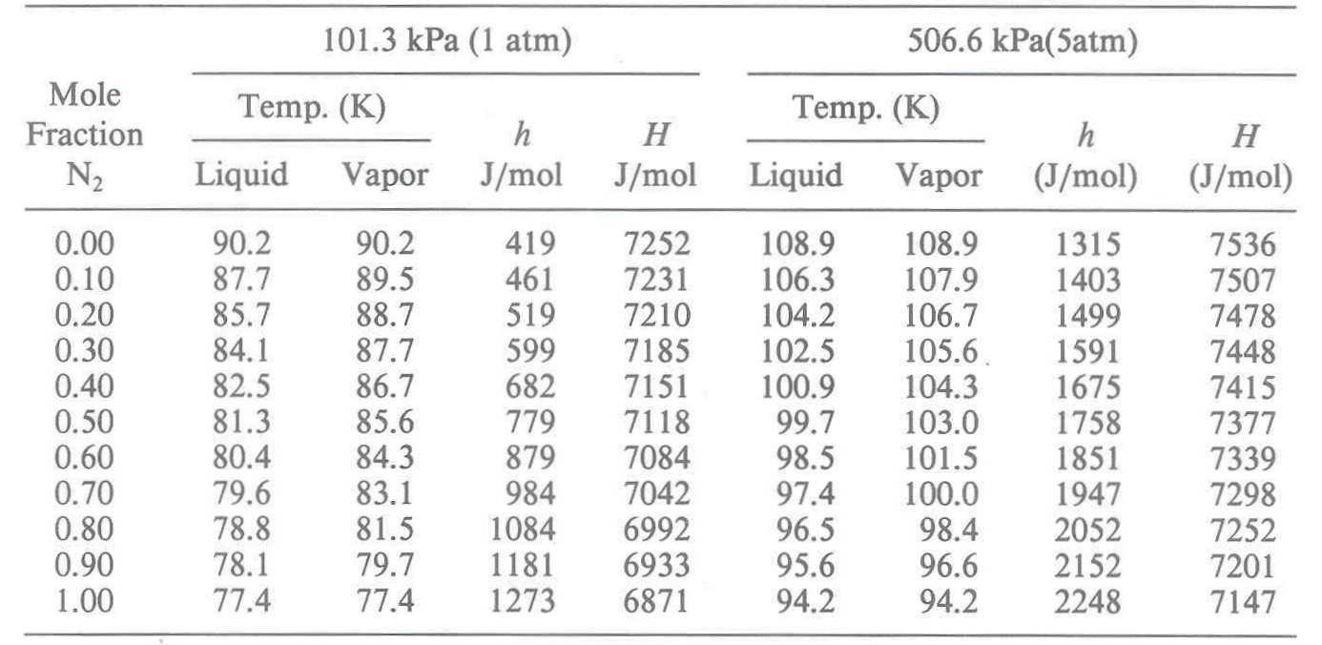

Fig. 1 Temperature-composition diagram for nitrogen-oxygen mixture

2. (1) Briefly explain the operation of the following Heylandt gas-separation system.
(2) Do your best to plot the cycle on the temperature-entropy diagram of air (you may assume the property of nitrogen and oxygen similar to air).

3. The figure below shows the Philips refrigerator using helium to keep a temperature at 100 K while rejecting heat to the ambient at 300 K. The minimum pressure of the system is 500 kPa and the maximum is 2,000 kPa.
(1) Plot the cycle on temperature-entropy diagram.
(2) Determine the refrigeration effect (heat absorbed per unit mass).
(3) What is the work requirement per unit mass compressed?
(4) What is COP (coefficient of performance)?
(5) Describe what will happen if the processes are not ideal, and the regenerator effectiveness is not 1.

4. The figure below shows the Gifford-McMahon refrigeration cycle.
(1) Explain the operation of the cycle.
(2) Plot the cycle on the temperature-entropy diagram.
(3) List the advantages and disadvantages of the cycle.
(4) Please mention the lubrication methods for the displacer.
(5) What is the best way to increase both the cooling capacity and COP?

5. The working medium is a paramagnetic material and thin lead strip is used as thermal valves in the magnetic refrigeration system.
(1) Explain its operation considering the temperature-entropy diagram.
(2) What is the main function of the thin lead strip as a thermal valve.
(3) How can you enhance the performance of the system?

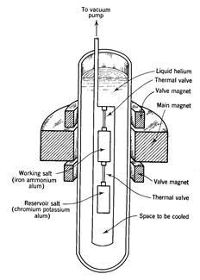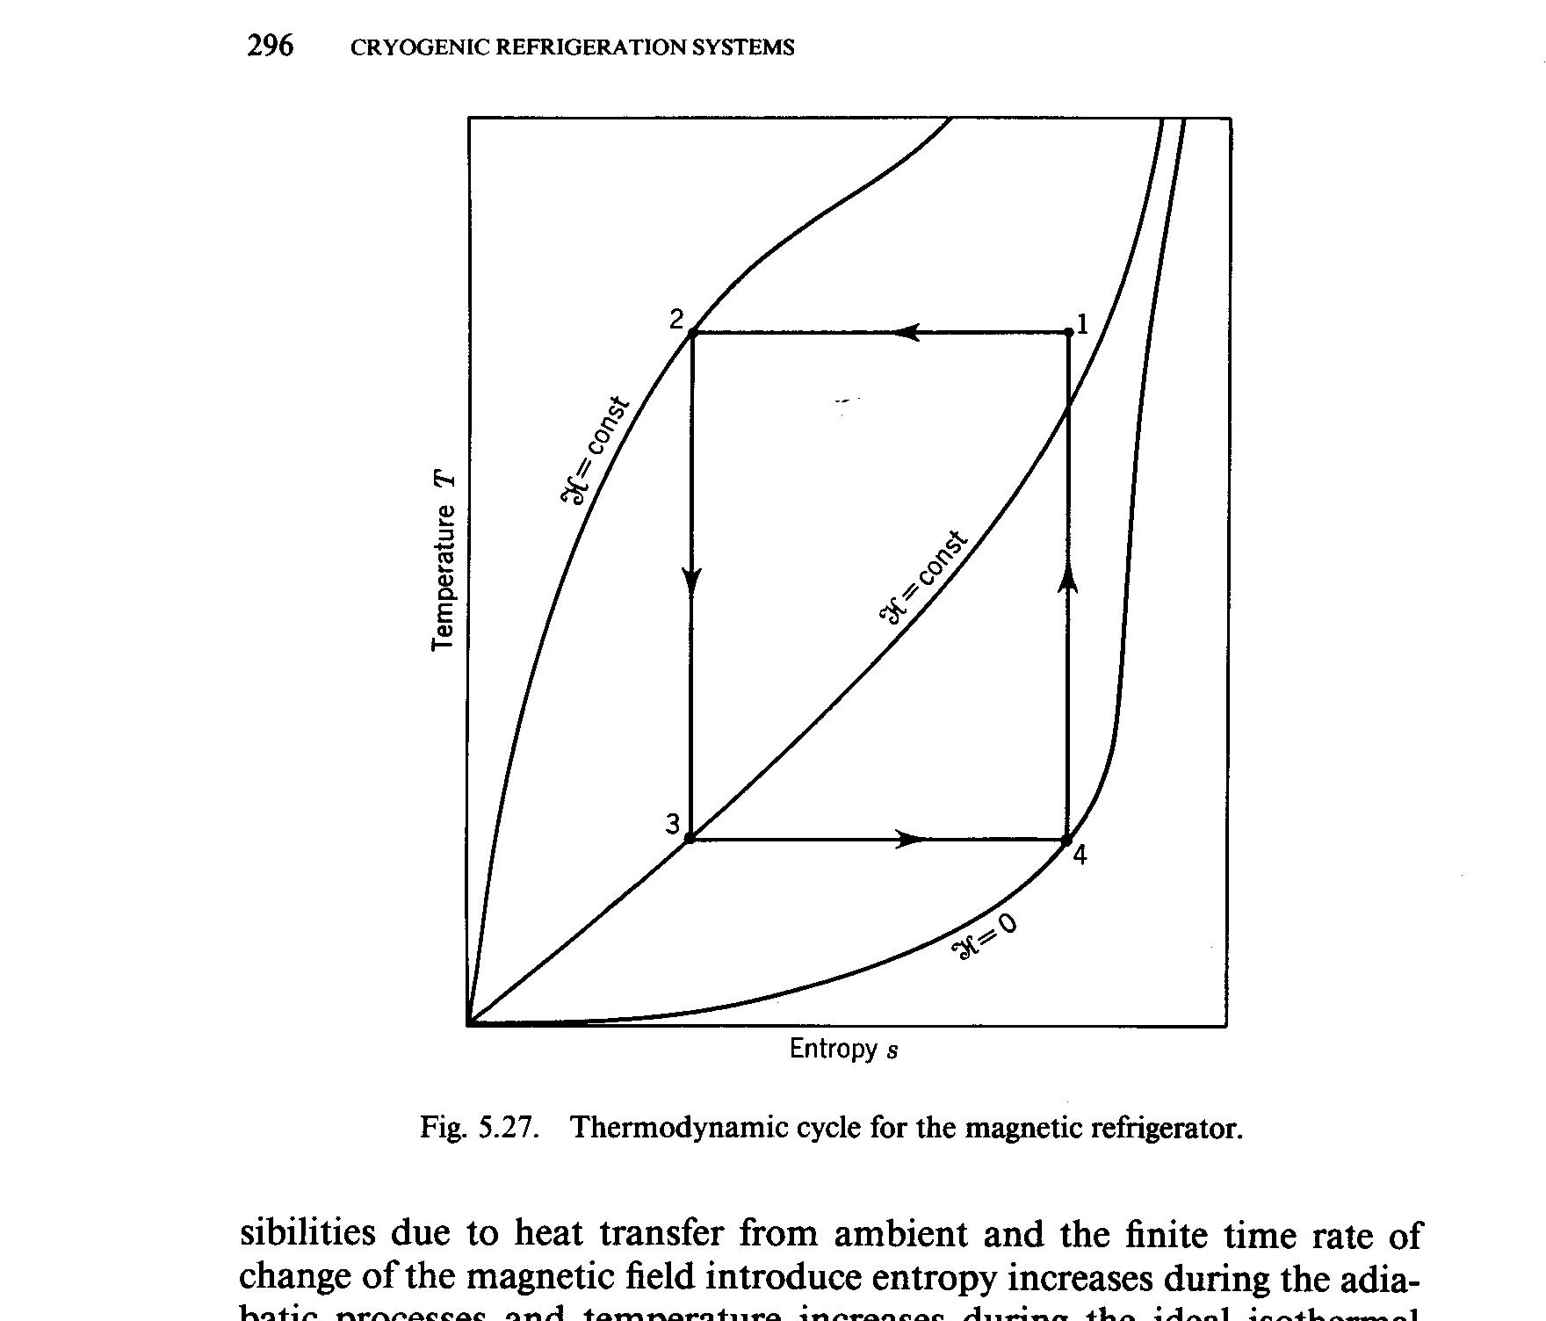
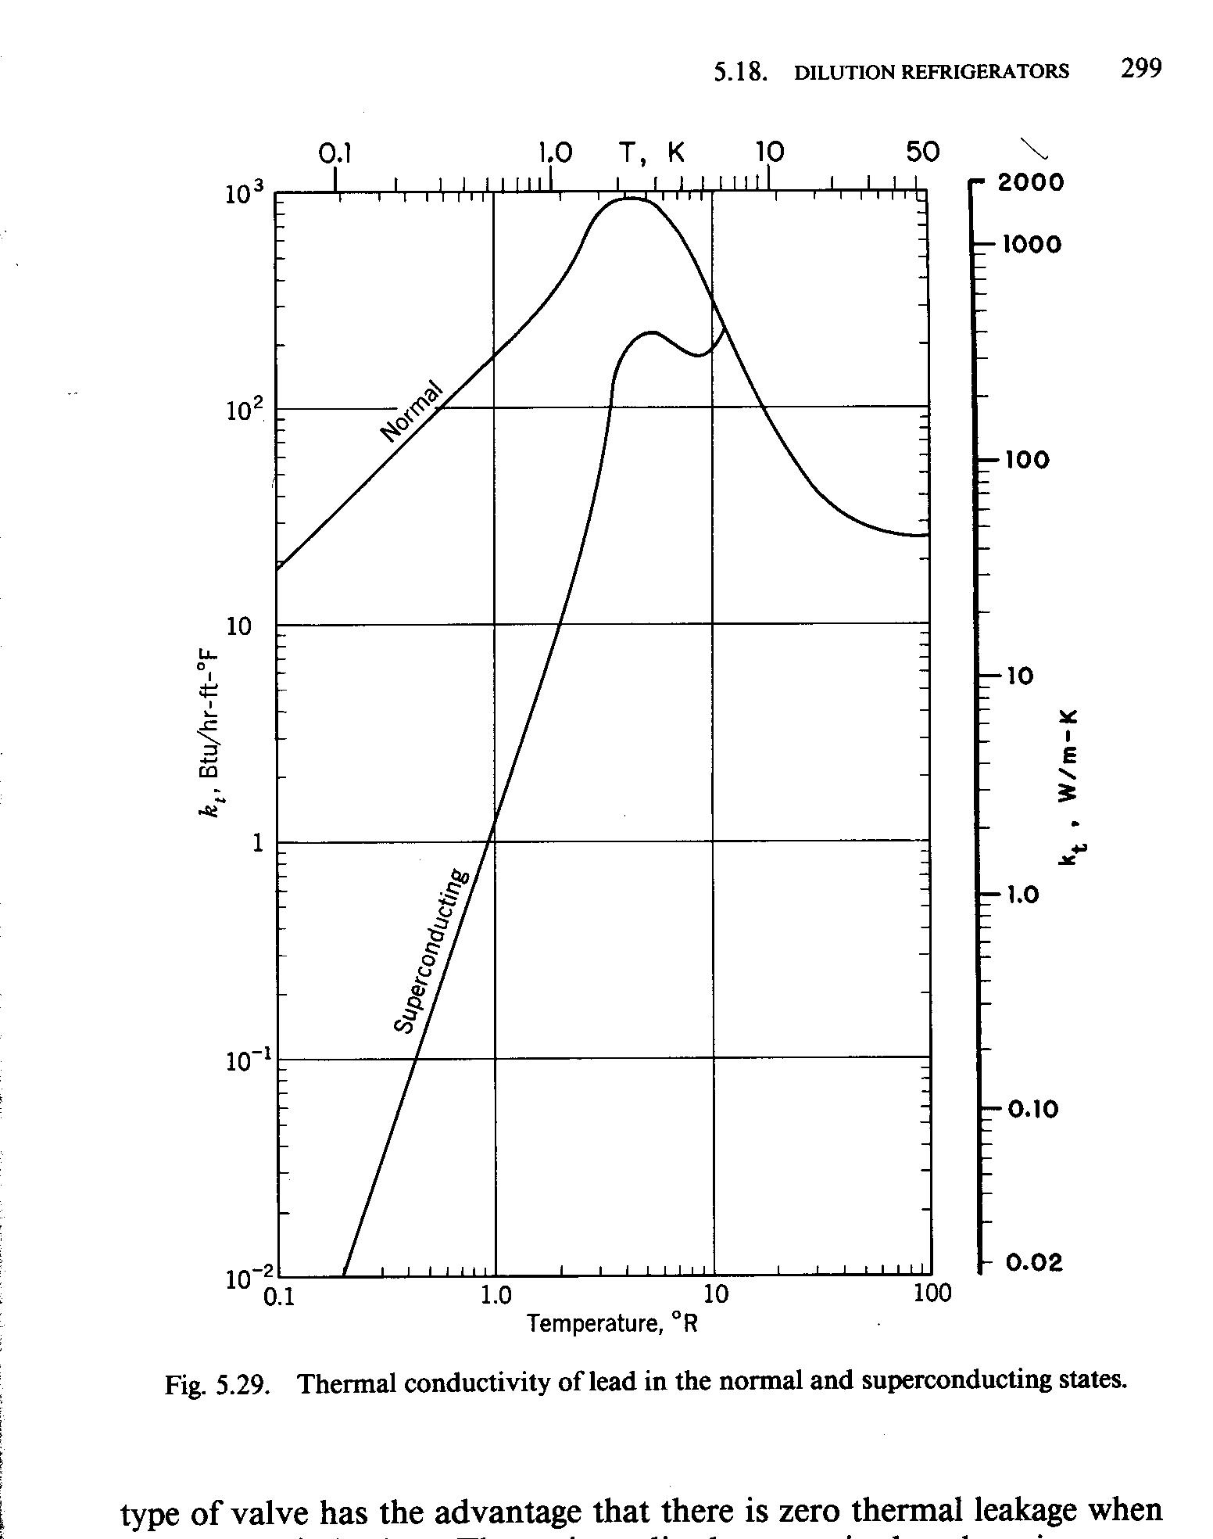

6. The following figure shows the cryogenic fluid storage and transfer system.
(1) Explain the main functions of diffuser.
(2) What is the best way to tighten the inner vessel?
(3) How can you measure the level of the cryogenic liquid in the vessel?
(4) Explain the thermal expansion/shrinkage of the storage system.
(5) When the cryogenic fluids are transferred, what kind of caution should be made?
(6) Draw a schematic diagram to take the 10 kg of cryogenic fluid out of the medium size vessel of 300 L. High pressure gas cylinder of the same fluid is ready.
