1. Calculate the number of theoretical plates in the rectification column for nitrogen-oxygen mixture which meet the following conditions.
ⅰ) $x_{F}F=x_{B}B+x_{D}D$
$\left(0.6\right)F=\left(0.05\right)B+\left(0.95\right)D$, Obtain B value.

ⅱ) $\dot{Q_{B}}=\dot{Q_{D}}+h_{D}D+h_{B}B-h_{F}F$, $\dot{Q_{B}}=500kW$
From table 2, $h=879J/{mol}$, $H=7084J/{mol}$
Suppose we take the average values of the saturated vapor and saturated liquid enthalpies at the feed stream condition. Then,
$$h=h_{D}=h_{B}=879 J/{mol}\left(saturated liquid\right)$$
$$H=7084 J/{mol}(saturated vapor)$$

ⅲ) The enthalpy of the feed stream is
$h_{F}=h=879J/{mol}$ (Because the state of the feed flow is the saturated liquid state)
$$\dot{Q_{B}}=\dot{Q_{D}}+h_{D}D+h_{B}B-h_{F}F$$
$\dot{Q_{D}}$ value can be obtained

iv) $\frac{D}{V_{n}}=\frac{H_{n}-h_{n+1}}{{(\dot{Q}}/D)-h_{D}-h_{n+1}}$
$$\frac{L_{n+1}}{V_{n}}=1-\left(\frac{D}{V_{n}}\right)$$
$$y_{n}=\left({L_{n+1}}/{V_{n}}\right)x_{n+1}+\left(D/{V_{n}}\right)x_{D}$$
v)$\frac{B}{V_{m}}=\frac{H_{m}-h_{m+1}}{({\dot{Q}}/{B)}-h_{B}+h_{m+1}}$
$$\frac{L_{m+1}}{V_{m}}=1+\left(\frac{B}{V_{m}}\right)$$
$$y_{m}=\left({L_{m+1}}/{V_{m}}\right)x_{m+1}+\left(D/{V_{m}}\right)x_{B}$$
vi)$q=\frac{H-h_{f}}{H-h}=1 ,$ saturated liquid feed
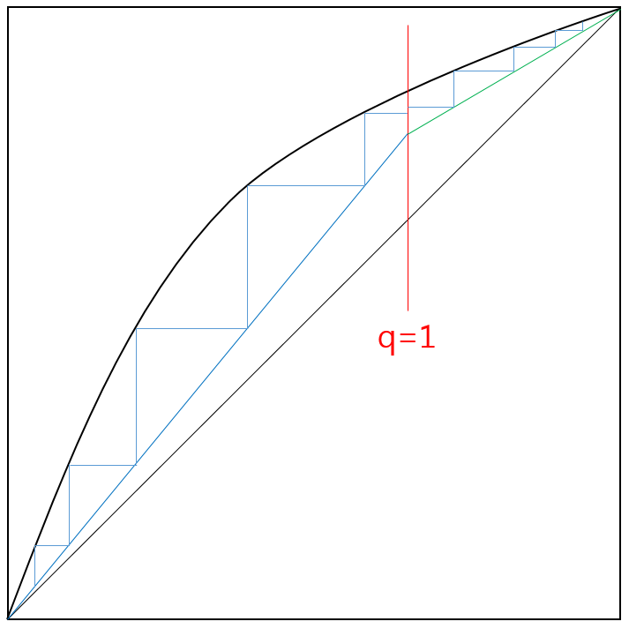

2.
(1) Briefly explain the operation of the following Heylandt gas-separation system.
The incoming air is compressed to 10MPa in a four-stage reciprocating compressor. Water vapor in the air is removed in the intercoolers and after cooler of the compressor. After removal of the water vapor, the air is compressed further to 13.7 MPa (135atm) in a compressor driven by an expansion engine. The air is then passed through a precooler and an ammonia forecooler and cooled to -40℃. Before the air stream is passed through the main heat exchanger, about half of the air is bypassed through an expansion engine and expanded to 700kpa and leaves the expander at 110K. The other half of the airstream passes through the main heat exchanger and is expanded through an expansion valve to 700kPa (7atm). The two airstreams are united and passed through a scrubber. The gaseous air from the scrubber is introduced near the bottom of the lower column, and the liquid air from the scrubber is passed through a filter to remove the carbon dioxide and hydrocarbon ice particles. The filtered air is united with the kettle liquid from the lower column, and both streams are introduced into the upper column.

(2) Do your best to plot the cycle on the temperature-entropy diagram of air (you may assume the property of nitrogen and oxygen similar to air).

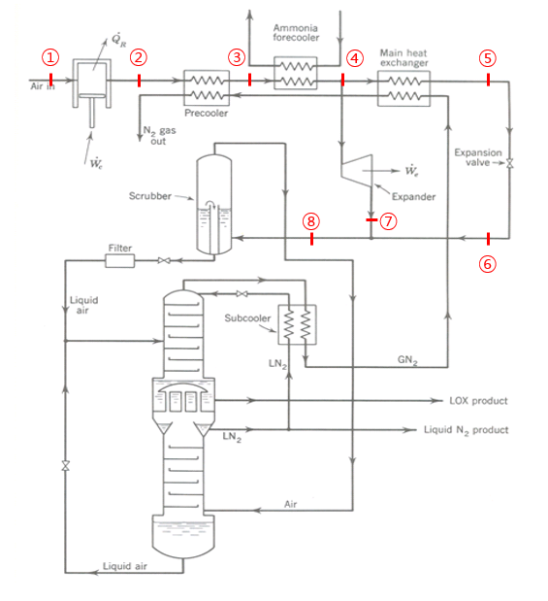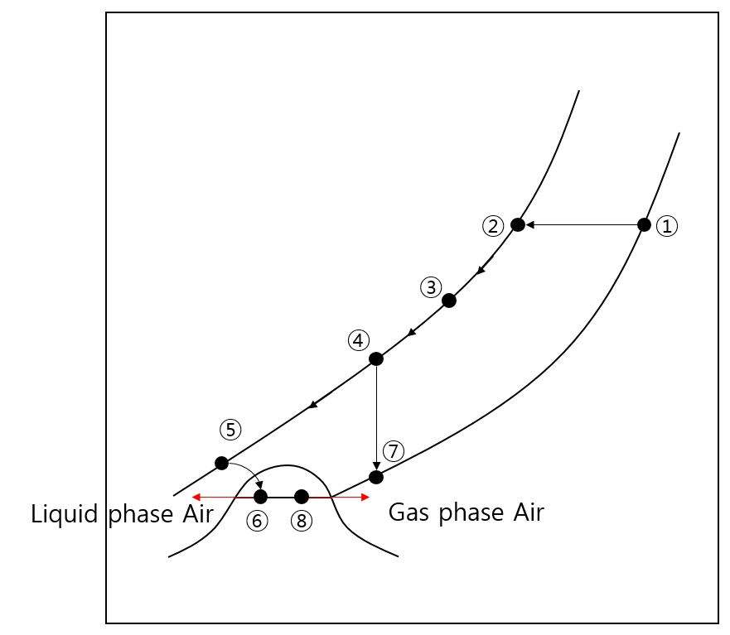

3.
(1)
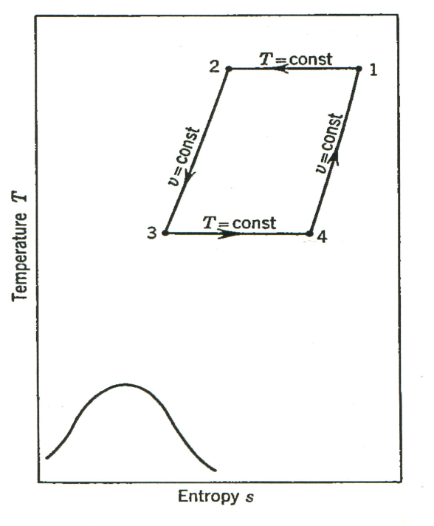
(2) $\frac{Q_{a}}{m}=T_{3}(s_{4}-s_{3})$
(3) $W_{net}=Q_{r}+Q_{a}=mT_{1}\left(s_{2}-s_{1}\right)+mT_{3}(s_{4}-s_{3})$
(4) COP=$\frac{{-Q}_{a}}{W_{net}}=\frac{T_{3}}{{T_{1}(s_{1}-s_{2}}/{(s_{4}-s_{3})}-T_{3}}$
(5)Frictional energy dissipation, pressure drops through the regenerator, finite temperature differences during heat rejection and heat absorption, and finite temperature differences between the regenerator and the working fluid all tend to lower the figure of merit in the actual refrigerator.

4.
(1) Processs 1-2. With the displacer at the bottom of the cylinder, the inlet valve is opened and the pressure within the upper expansion space is increased from a low pressure $p_{1}$ to a higher pressure $p_{2}$. The volume of the lower expansion space is practically zero during this process because the displacer is at its lowest position.
Process 2-3. With the inlet valve still open and the exhaust valve closed, the displacer is moved to the top of the cylinder. This action moves the gas that was originally in the upper expansion space. Because the gas is cooled as it passes through the regenerator, it will decrease in volume so that gas will be drawn in through the inlet valve during this process to maintain a constant pressure within the system.
Process 3-4. With the displacer at the top of the cylinder, the inlet valve is closed and the exhaust valve is opened, thus allowing the gas within the lower expansion space to expand to the initial pressure $p_{1}$. The gas that is finally within the lower expansion space does work to push out the gas that leaves during this process; therefore, energy is removed as work from the gas finally left in the lower expansion space. This causes the gas in the lower expansion space to drop to a low temperature.
(2)
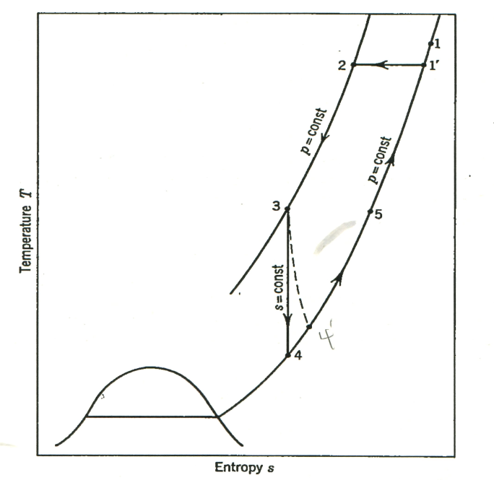

(3) Advantages
There is practically no leakage past the displacer in the Gifford-McMahon system because of the small pressure difference across the displacer seals
The displacer and crank arm in the Gifford-Mcmahon system need not be designed to support a large force; therefore, the motion transmission system can be quite simple and subject to fewer problems with vibration.
Disadvantages
The coefficient of performance of the Solvay system is inherently higher than that of the Gifford-McMahon system because more energy is removed from the working fluid by the external-work-producing process.
In the Gifford-McMahon system, a small motor is required to move the displacer back and forth while the expanding gas moves the piston in the Solvay system.
(5)There are several factors that contribute to a loss in performance of the Gifford-McMahon refrigerator, incluiding the regenerator ineffectiveness, thermal conduction down the displacer and its housing, “shuttle” heat transfer, and the finite volume within the regenerator. By improving these things, we can increase both the cooling capacity and COP.

5.
(1) Process 1-2. The magnetic field is applied to the working salt while the upper thermal valve is open and the lower thermal valve is closed. When the upper thermal valve is open, heat may be transferred from the working salt to the liquid-helium bath, thereby maintaining the salt temperature fairly constant. The thermal valve between the working salt and the reservoir salt is closed so that heat will not flow back into the low-temperature reservoir during this process.
Process 2-3. Both thermal valves are closed, and the magnetic field around the working salt is reduced adiabatically to some intermediate value. During this process, the temperature of the working salt decreases.
Process 3-4. The thermal valve between the working salt and the reservoir salt is opened, and the field around the working salt is reduced to zero while heat is absorbed isothermally by the working salt from the reservoir salt.
Process 4-1. Both thermal valves are closed, and the magnetic field around the working salt is adiabatically increased to its original value.

(2) Thin lead strips were used as the thermal valves. It was observed that the thermal conductivity of lead was different in the superconducting state compared with the normal state. When the material is below the transition temperature in zero field, many of the electrons that would ordinarily take part in the heat-transport process are restricted from doing so because of the quantum considerations of the superconducting state.
When a magnetic field is applied to the lead strips, the lead is driven into the normal state if the applied field is above the transition value, and the electrons are once again free to take part in the heat- transport process.
(3) In the ideal case, the refrigerator cycle is a Carnot cycle. However, irreversibilities due to heat transfer from ambient and the finite time rate of change of the magnetic field introduce entropy increases during the adiabatic processes and temperature increases during the ideal isothermal processes. To enhance the performance of the system, Zimmerman et al used superconducting magnets instead of ordinary magnets.

6.
(1) Explain the main functions of diffuser.
A vapor diffuser must be incorporated in the vent line in order that that warm presurrization gas be distributed within the ullage space(vapor space above the liquid) and in order that the warm gas be directed away from the surface of the cold liquid to reduce recondensation of the pressurization gas.

(2) What is the best way to tighten the inner vessel?
The inner vessel is designed to withstand only the internal pressure and bending forces, and stiffening rings are used to support the weight of the fluid within the lower vessel.

(3) How can you measure the level of the cryogenic liquid in the vessel?
- Hydrostatic gauges
- Electric-resistance gauges
- Capacitance liquid-level probes
- Thermodynamic liquid-level gauge

(4) Explain the thermal expansion/shrinkage of the storage system.
Cryogenic-fluid storage vessels are not designed to be completely filled for several reasons. Heat inleak to the product container is always present So, the vessel pressure would rise quite rapidly because of vaporization of the liquid if no vapor space were allowed. And, inadequate cool-down of the inner vessel during a rapid filling operation would result in additional boil-off, and the liquid would be percolated through the vent tube if no ullage space were provided. A 10 percent ullage volume is commonly used for large storage vessels. Moreover, due to the heat inleak, usually spherical vessels are considered as the most effective configuration.

(5) When the cryogenic fluids are transferred, what kind of caution should be made?
- The thermal contraction of the piping runs could be happened(long enough length piping line is necessary)
- Excessive pressures damage the inner vessel(inner vessel pressure-relief valve should be installed)

(6) Draw a schematic diagram to take the 10 kg of cryogenic fluid out of medium size vessel of 300 L. High pressure gas cylinder of the same fluid is ready.

