Organic Chemistry 2 2008 Exam 1 Student ID # Name .
Total 100 points. Write your answers in the space provided. If you need more space, write on the back.
- (24 points) Write the name of the following compounds.

2. (7 points) What is the structure of the compound described by the spectral data below?
Formula C₈H₈O₂
IR (cm^{–1}) 3050, 2950, 2800, 1700, 1490, 1100
¹H NMR δ 3.73, 3 H, singlet
δ 6.96, 2 H, doublet
δ 7.70, 2 H, doublet
δ 9.87 , 1 H, singlet

3. (6 points) Predict three major fragmentation products from the following compound in Mass Spectrometry?

4. (3 points) Which of the following has the lowest energy λ_{max} and explain why?

A B C D E
5. (20 points x 3) Identify the structure of the following compounds, A, B, and C, based on the spectral data provided on the following pages, respectively. Try to assign as many peaks in the spectra as possible for the full credit and you should show your peak assignments directly on top of the spectra. Write down the proposed structure and your reasoning process on this page. You will get a partial credit even for the wrong structure only when your analytical process makes sense and bonus 2 points for the name given for each compound.
(a) A

(b) B

(c) C

Compound A

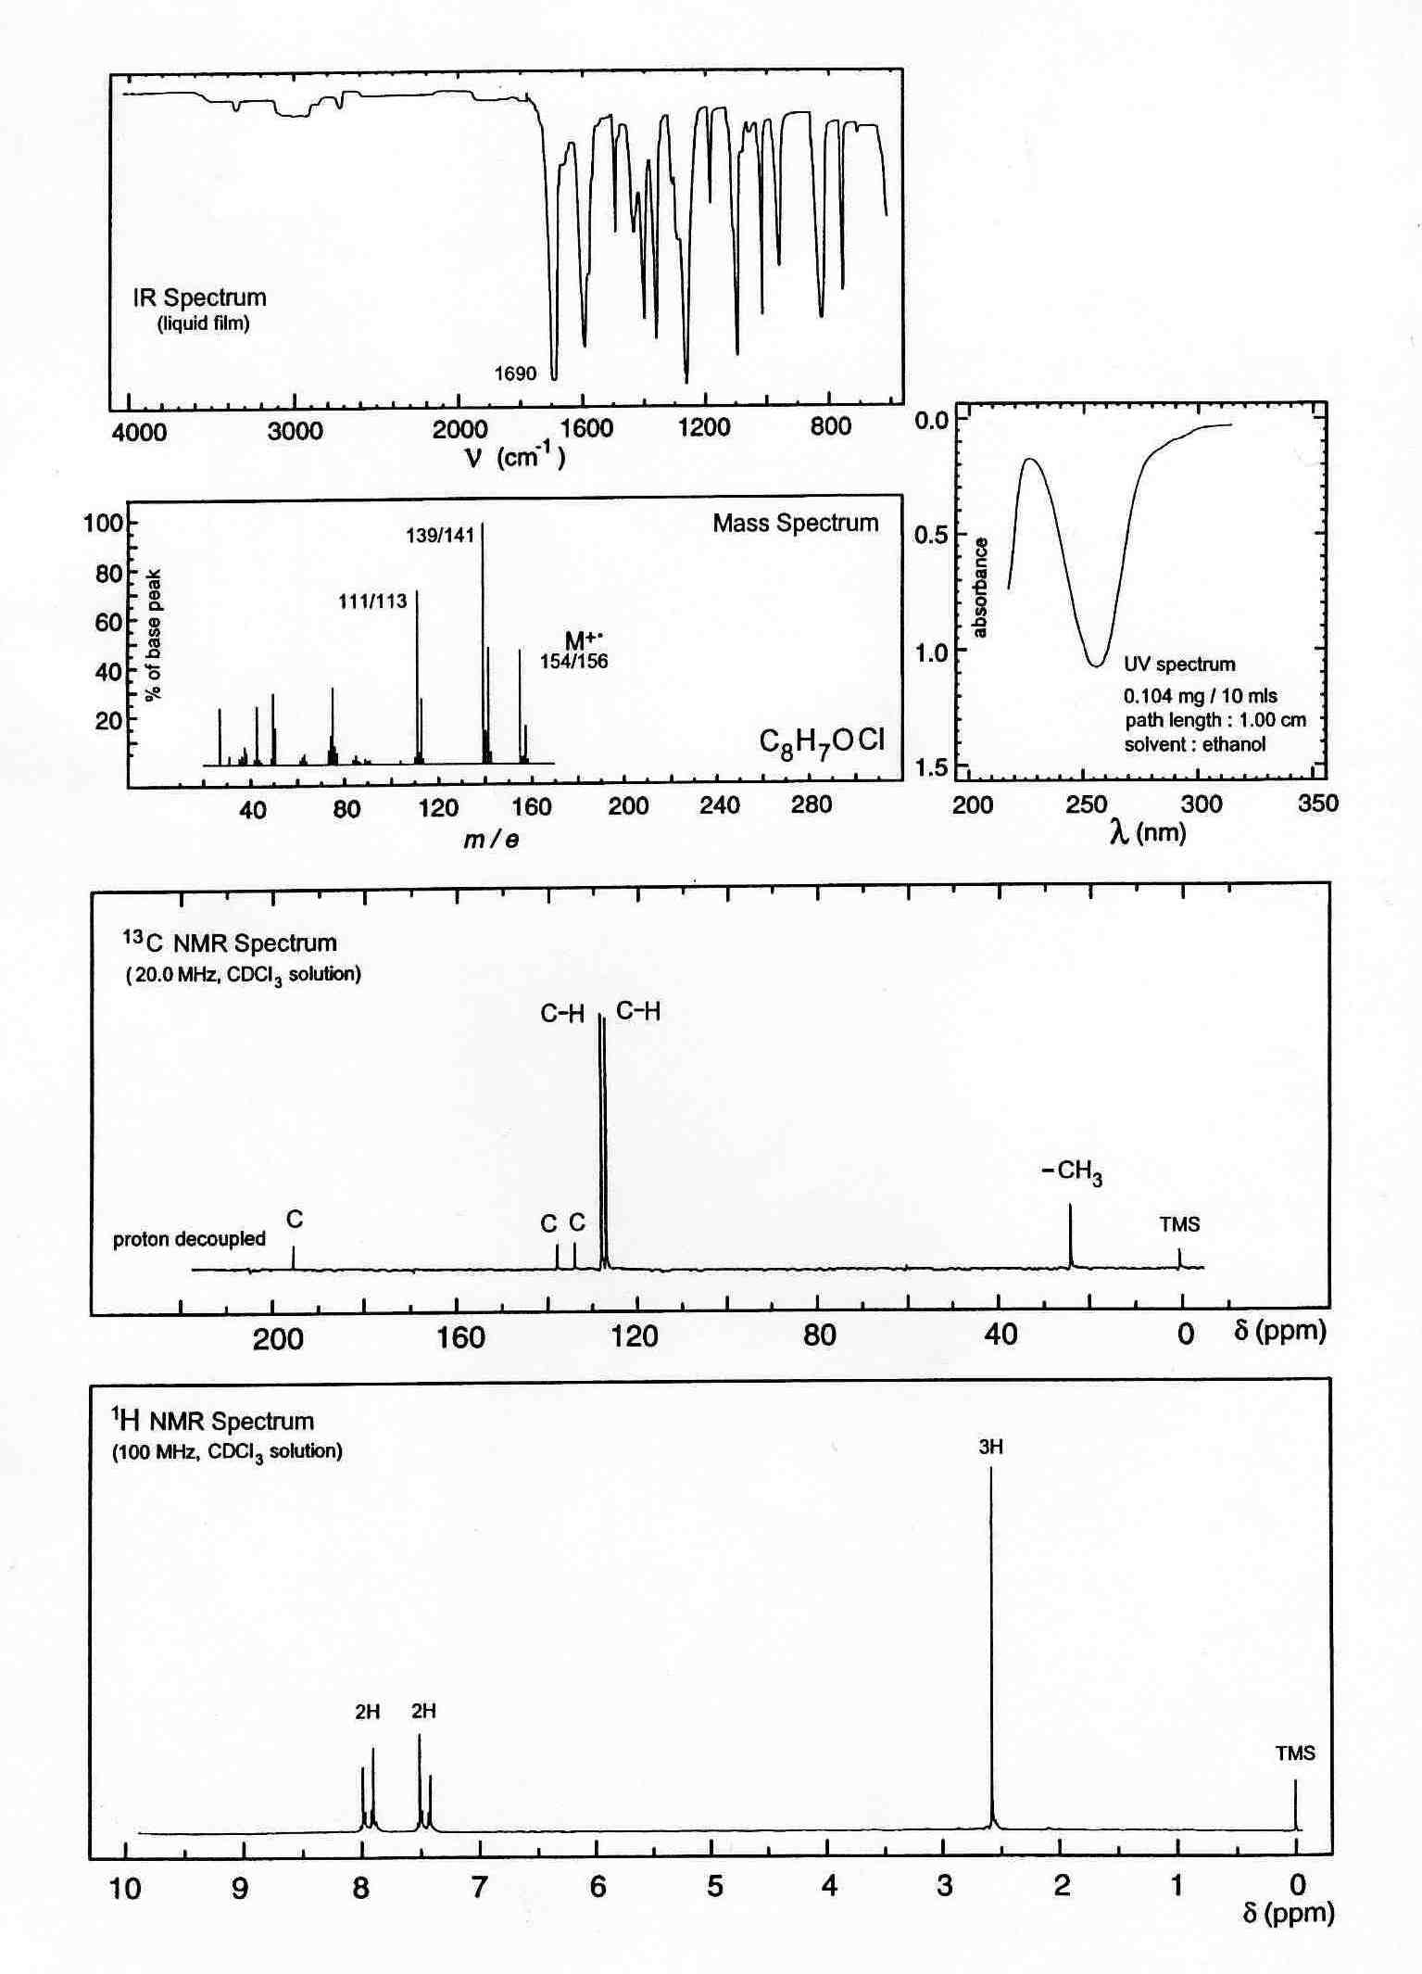
2
2
3

2

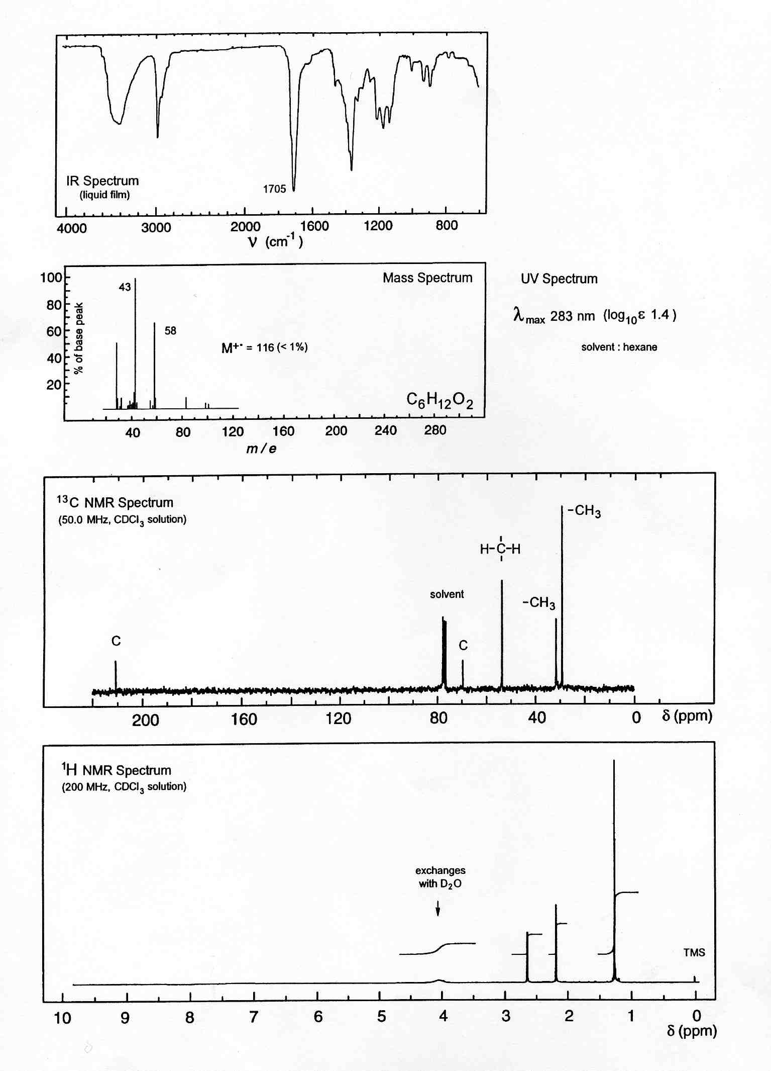
Compound B
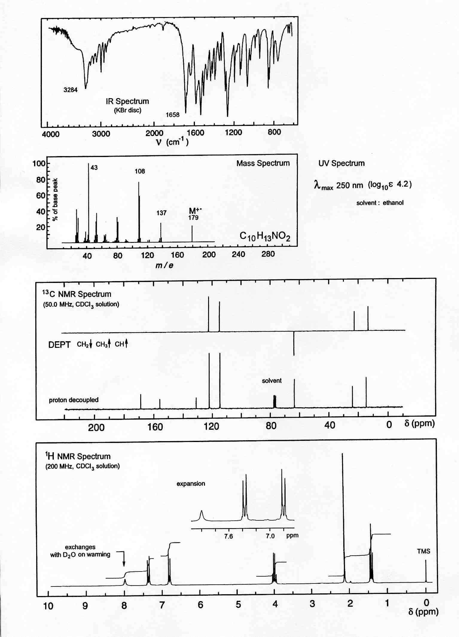
1
1
Compound C

