2008 Spring Semester, Thermodynamics of Material

16, April (Wed) total 110 point

Midterm Exam

1. A ball was falling from the air, bouncing up and down several times by elastic force and then finally stopped on the floor. Explain this phenomenon based on thermodynamics 1st law and 2nd law. (10 pt)

2. 5 moles of ideal gas are contained adiabatically at 300K and 50 atm. When the pressure was suddenly reduced to 10 atm, the gas was expanded irreversibly, performing 4000 joules of work. The constant volume heat capacity, Cv of ideal gas is 1.5 R.

1. Calculate the temperature of the expanded gas. (10 pt)
2. If the gas was expanded reversibly from 50 atm to 10 atm, what is the temperature of the gas (T2)? (10 pt)

(Hint: PVγ = constant, where γ = Cp/Cv , under reversible expansion)

1. Calculate the entropy generated from the irreversible expansion in the following way.

(3-1) A reversible change from an initial state to T1 at constant volume followed by reversible isothermal expansion. (10 pt)

(3-2) Reversible adiabatic expansion from an initial state to TZ followed by reversible isobaric expansion. (10 pt)

3. Consider gas A which was divided into 2 moles and 1 mol of the same volume by a partition as shown below. Then, the partition in the box was removed. Calculate the entropy increase by the Boltzmann method. (20 pt)

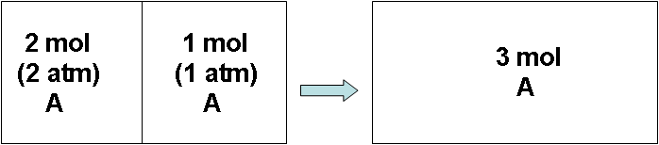

4. At the Einstein crystal, the atoms are assumed as harmonic oscillators, and the energy of the “i”th level is given as follow.



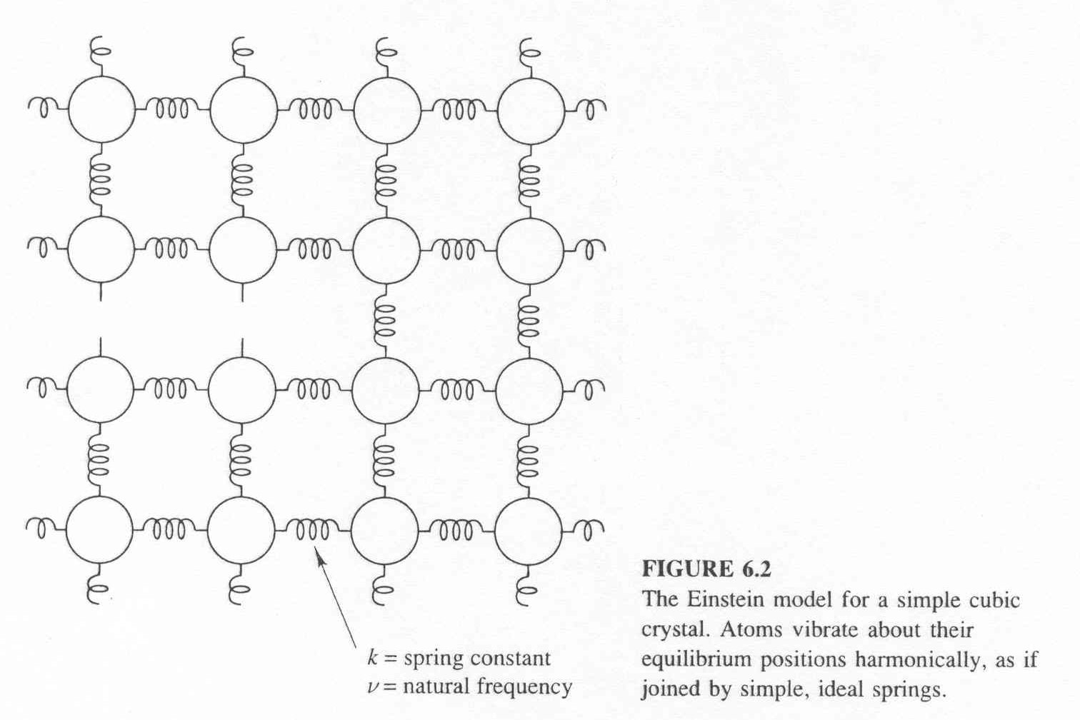

1. Derive the partition function of the Einstein crystal. (10 pt)
2. Derive the entropy of the Einstein crystal. (10 pt)
3. Derive the internal energy of the Einstein crystal. (10 pt)
4. Derive the constant volume heat capacity of the Einstein crystal. (10 pt)

(Hint: Helmholtz free energy can be written as F = - NoKTlnP when the total number of atoms or molecules is No, Boltzmann constant is k, partition function is P.)