2008 Spring Semester, Thermodynamics of Materials

Final exam

1. The following C-H-O ternary diagram shows the areas of diamond deposition, non-deposition, and non-diamond deposition by microwave plasma CVD, HWCVD, or flame deposition. Explain the reason of this deposition behavior.

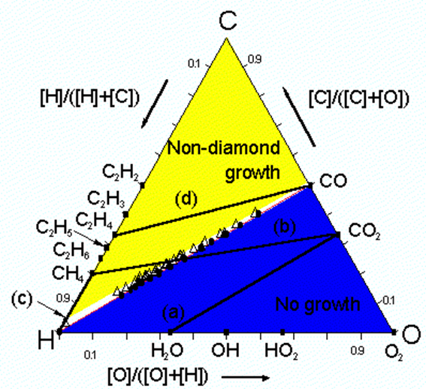

2. The following data show the calculation result of the final equilibrium including the condensed phase and the metastable equilibrium excluding the condensed phase, under the conditions of the gas ratio of SiH4 : CH4 = 1 : 1, temperature of 1400K, and reactive pressure of 1000 Pa. Calculate the supersaturation ratio for deposition of SiC under these conditions.

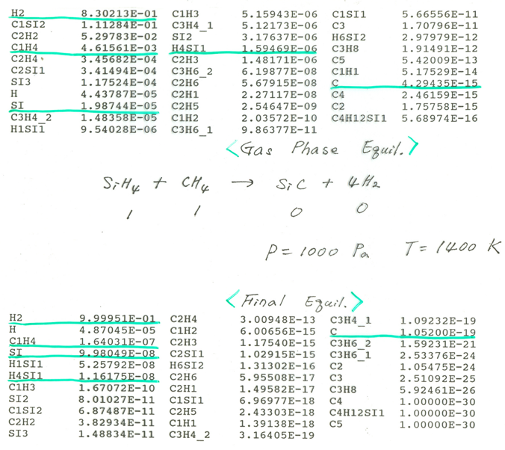

3. The microstructure shown below indicates the Si deposition behavior on the substrate which has regular SiNx patterns on the SiO2. The temperature of the substrate is 950°C, the reactive pressure is 150 mTorr, and the reactive gas ratio is SiH2Cl2: HCl : H2 = 0.53 : 1.8 : 100 (liter/min).

Explain the deposition behavior based on the following view points.

1. Why does Si selectively deposit on SiNx pattern, but not on the SiO2?
2. Why does Si deposit in the beginning, but etch in the end?
3. Why does only a single large Si particle grow finally?



4. In terms of thermodynamics and kinetics, compare two diamond CVD processes: the old one done by Angus at Case Western University and Eversole at Union Carbide in 1950s and 1960s, and the new process using hot filament or microwave plasma invented in 1980s.