Water Wave Mechanics ('08 Spring)
Mid-Term Exam

1 (20) The equations for an average viscous flow through a porous medium are defined by
$\frac{∂p}{∂x}=\text{Ku}$
$\frac{∂p}{∂y}=\text{Kv}$
where $p$ is the hydrostatic pressure and $K$ is a constant. Demonstrate that such a flow is irrotational. On the other hand, the equations for an average fully turbulent flow through rocks are
$\frac{∂p}{∂x}={\text{Ku}}^{2}$
$\frac{∂p}{∂y}={\text{Kv}}^{2}$
Demonstrate that such a flow is in general rotational.

2 (30) Often the seabed is covered with ripples. The total still-water depth, $h'(x,y)$, can be described as $h'=h(x,y)−δ(x,y)$, where$h(x,y)$ is a slowly varying depth and $δ(x,y)$ represents rapid undulations of the depth about $h(x,y)$ as shown below (Kirby, 1986, JFM, Vol. 162). We assume
$O\left(\frac{∇_{h}h}{\text{kh}}\right)≈O(kδ)\text{<<}1, ∇_{h}=\frac{∂}{∂x}\vec{i}+\frac{∂}{∂y}\vec{j}$
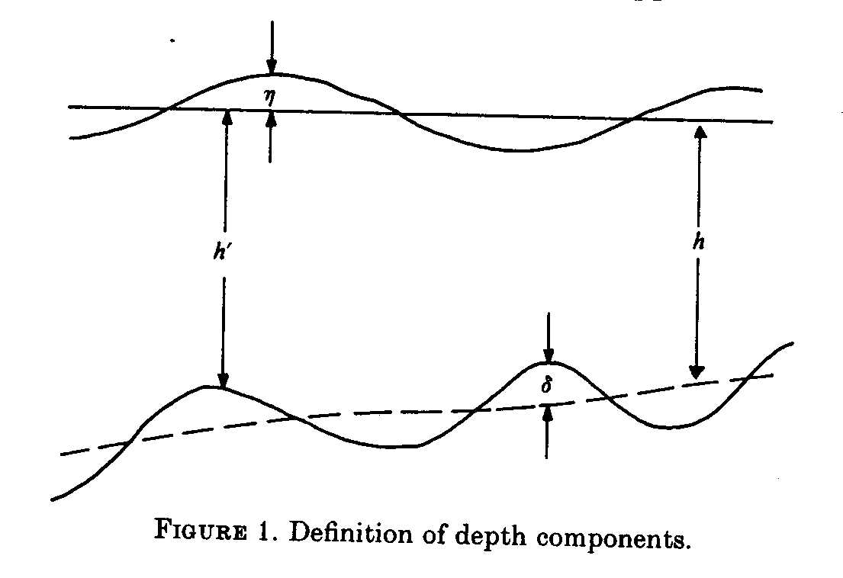

(a) Find the exact bottom boundary condition.
(b) Find the bottom boundary condition to $O(kδ)$ by expanding the bottom boundary condition about $z=−h$.

3 (25) A small amplitude wave of period $T$ = 6.28 s, has traveled over a gently sloping bottom from deep water to a depth of 9 m, where it is observed to have a wave height $H$ = 0.9 m.
- What is the wave length and the phase velocity of the wave in 9 m of water?
(b) What is the deep water wave height, $H_{0}$? Assume the waves to be of normal incidence.

4 (25) Waves generated by a storm range in periods ($T$) from 5 to 20 seconds. Assuming deep-water conditions for the entire travel distance, apply the linear wave theory to construct a rough graph of travel time versus $T$ for a beach 1,000 km from the storm area. How much later do the 5-s waves arrive at the beach than the 20-s waves?

