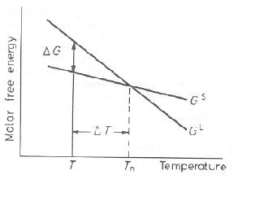
- This diagram shows the Gibbs free energy of liquid and solid state. Derive an equation for a driving force at temperature T. (When T and T_{m} is close each other.)

- In the nature, it is hard to find a material without any kind of impurities. It is also true in laboratory. Please explain the reason for hardly finding a pure material based on your Phase transform knowledge. (Including equations)

- There is a solution mixed with A and B.

- How can you derive an equation for ε, the average difference between bonding energy of A-B, A-A, and B-B?

- How can ΔG_{mix} be expressed for each IDEAL SOLUTION and REGULAR SOLUTION? And, what should be assumed for expressing that equation? (explain relating to ε)

- Explain the difference between the cases for ε<0 and ε>0 at both relatively low temperature. And, what would be different when the temperature is elevated? What is the reason?

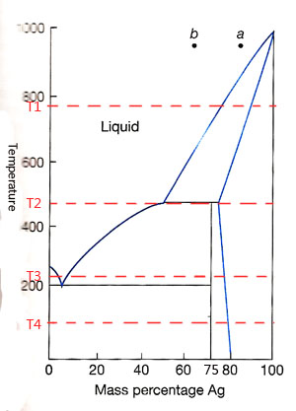
4. The diagram on the right is Ag-Sn phase diagram. Answer the questions based on the diagram. (20pt)

- Label each region in the diagram.

- Draw composition-Gibbs energy diagrams for each given 4 temperature.

- Assume that at each component a and b, temperature is lowered to 200℃. Explain what phenomena occur passing through each region.
- There is a thin film that Si and Ge are deposited without any dislocation or grain boundary at the same lattice. Assume that the intrinsic diffusivity is D_{Ge}>D_{Si} and the substitutional diffusion occurs for each other. Then, answer the below questions with appropriate diagrams. (Complicated derive is unnecessary.) (20pt)

- The atomic flux of each Si and Ge
- Flux of vacancies
- Interface motion
- Vacancy creation/annihilation

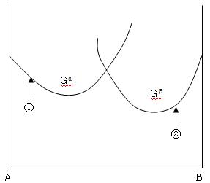
- The diagram below shows when component A and B are mixed at arbitrary temperature, T₁. The phase α with composition ① welds to phase β with composition ②, and they are tempered at temperature T₁. (20pt)

- Considering chemical potential of A and B in the phase α and β, show where each atom is diffused into and what composition is reached at the equilibrium. (Show every composition and chemical potential for before and after equilibrium.)

- Explain briefly why the state you explained above is equilibrium.

- Show this motion reduces total molar free energy.

