**1. The ice has the hexagonal shape with singular interface at the equilibrium. However, when you observe the snow with a microscopy, you can see that it has grown as a dendritic shape instead of a flat shape. Explain why this phenomenon has occurred. (10 pt)**

Phase Transformation Final Exam 2008.12.11.Thu

**2.**



**Assume that heterogeneous nucleation has occurred on a flat surface as the picture above.**

**(a) If the nucleus has spherical cap shape with the angle contact to the surface is θ and radius is r, show the volume(V) of nucleus and the area of the interface(ASL, ASM) with r and θ. (15pt)**

**(b) Derive the change of Gibbs free energy (ΔGhet) by the equation derived at (a). (5pt)**

**(c) Derive the critical radius r* and activation energy of nucleation (ΔGhet*) by equations derived above. (5pt)**

**3. There is a crystal made of {100} planes at the equilibrium. Suppose that this grows by homogeneous nucleation with equilibrium shape.**

**a) Calculate the critical nuclei size of one plane. (5pt)**

**b) Calculate the free energy barrier. (5pt)**

**When this crystal is placed on a substrate, it turns into a tetragonal with each width and length is a and height is x.**

**c) Suppose that the surface energy of {100} is A, surface energy of substrate is B, and the interfacial energy between the crystal and substrate is C. Derive x with a, A, B, C. (15pt)**

**4. (Solidification of alloy)**



**There is an alloy which has a phase diagram shown above.**

1. **When you put this in an 1-Dimensional bar shown below and solidify it decreasing temperature from T1 to TE , show the migration of the solid/liquid interface and each change of solute concentration at T1, T2, TE as diagrams. (Suppose that diffusion hardly occurs in solid and the liquid can be the perfect mixing condition by appropriate agitation.)**

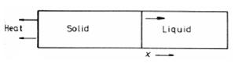

1. **Why the liquid phase is still left under T3? Show how this phenomenon would change the phase diagram. (15pt)**

**5. 다음은 이성분계 합금의 조성에 따른 Gibbs 자유에너지 변화를 나타낸 것이다. 그림과 같이 합금이 있을 때, 조성이 Xo과 Xo’에서 상이 분리될 때 다른 양상을 나타낸다. 이때의 차이점을 열역학적 지식을 활용하여 설명하라. 특히 Xo’의 경우는 농도가 낮은 쪽에서 높은 쪽으로 확산이 일어나는데 이것이 왜 가능한지 설명하라. 또한 시간에 따른 조성의 변화(schematic composition profiles at increasing time & distance)를 그림으로 나타내어 보아라. (15점)**

**The diagram below shows the change of Gibbs free energy when the concentration of bi-component alloy is changing. When the phases are separated at Xo and Xo’, each progress is different. Explain the difference based on your Thermodynamical information. Especially in the case of Xo’, diffusion occurs from higher concentration region to the lower one. Explain why this is possible. Besides, show the schematic composition profiles at increasing time and distance with a diagram. (15pt)**

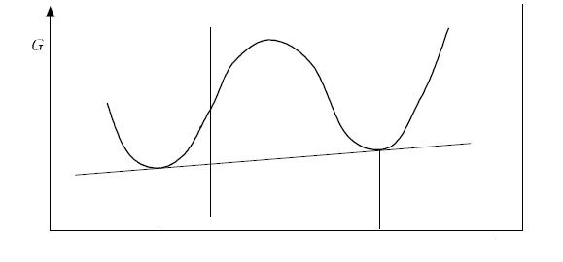

**Xo**

**Xo’**

**A**

**B**

**6. Sometimes solidified nucleus grows with dendritic interface, not necessarily with planar interface. Explain the necessary conditions for growth of protrusion from the planar interface and the formation progress with an appropriate diagram (composition profile along distance around the interface and temperature profile). (10pt)**

**액체에서 고체로 응고되는 과정에서, 꼭 planar interface가 아닌 dendritic interface를 가지면서 성장하기도 한다. Planar interface에서 안정한 돌출 부위가 형성되어 성장하기 위한 필요조건을 쓰고, 그 형성과정을 그림(interface 주위의 거리에 대한 Composition profile, 온도 분포)과 함께 설명하여라. (10점)**

1번 해설 🡪 [Kinetic Roughening]

물질의 과포화도(α)에 따라서 다음 그림과 같이 표면에는 screw-dislocation이나 2D nucleation이 많이 발생한다.



이것은 표면이 (atom이 붙기 위한) kinetic barrier가 거의 없거나 낮아진 상태가 된 것으로서, 이러한 조건이 갖추어지면 표면은 interface controlled에서 diffusion controlled의 특성을 보인다.

Diffusion-controlled interface에서는 농도에 따른 flux의 정도에 따라 평형상을 만들기보다 한 방향으로 치우친 경향을 보이는 성장을 한다. 이것은 물질의 성장에 있어, 열역학적 평형 조건보다 동역학 또는 속도론적인 조건(kinetic)이 우세하게 작용하기 때문으로, 이러한 현상을 Kinetic Roughening이라고 한다.

(3(c)의 풀이와 답)

