CFD Application to Ship Hydrodynamics
Mid-term Test

Time: 1:00PM – 3:00PM Tuesday, Oct. 14, 2008
Location: 34-119 SNU

Note: Answer in English

- (20 pts) For $y=sin\frac{πx}{2}$, obtain $\frac{dy}{dx}$ at $x=0.5$ with $∆x=0.1$ using:
- $\frac{dy}{dx}≈\frac{y_{j+1}-y_{j-1}}{2∆x}$,
- $\frac{dy}{dx}≈\frac{y_{j+1}-y_{j}}{∆x}$
- $\frac{dy}{dx}≈\frac{y_{j-2}-8y_{j-1}+8y_{j+1}-y_{j+2}}{12∆x}$
and compare the accuracy of the results.

- (10 pts) Repeat Problem 1 with $∆x=0.05, 0.025, 0.0125$ and determine whether the convergence with $∆x$ is consistent with the leading term of the truncation error.

- (25 pts) For $y=sin\frac{πx}{2}$, obtain $\frac{d^{2}y}{{dx}^{2}}$ at $x=0.5$ with $∆x=0.1, 0.05, 0.025, 0.0125$ using:
- $\frac{d^{2}y}{{dx}^{2}}≈\frac{y_{j-1}-2y_{j}+y_{j+1}}{{∆x}^{2}}$,
- $\frac{d^{2}y}{{dx}^{2}}≈\frac{{-y}_{j-2}+16y_{j-1}-30y_{j}+16y_{j+1}-y_{j+2}}{12{∆x}^{2}}$
and compare the accuracy of the results and the convergence with the leading term in the truncation error.

- (30 pts) Develop a finite volume discretization for mesh point A(i,j), with the control volume BCDGHKEF in the figure below.
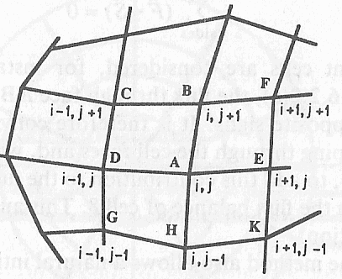
Compare the results from the evaluation of the side fluxes by the following three options, written for, e.g., side K(E)F:
- 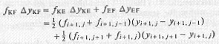

- (15 pts) Discuss the pros and cons of the following pairs.
  - FDM vs. FVM
  - Structured grid vs. Unstructured grid
  - Upwind approximation vs. Central approximation

