- semiconductor device mid-term exam

Constants:
K_{s} = 11.8, q = 1.6 x 10⁻¹⁹ C, ε₀=8.85 x 10⁻¹⁴ farad/cm, n_{i} = 10¹⁰ /cm⁻³ (T=300K), kT/q = 0.0259V (T=300K)

1. Answer following questions
(a) The lattice constant of Si is 0.543 nm. Using this value, determine the number of Si atoms/cm³.
(b) Briefly explain the effective mass. (Fewer than three lines)
(c) Explain the reason why Si cannot be used as photoelectric material. Use energy band diagram of Si.
(d) Derive the Einstein Relationship
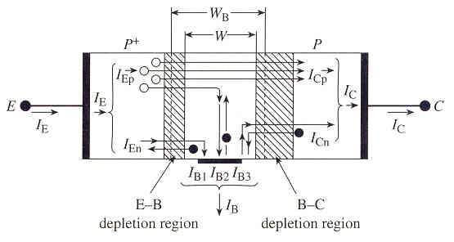
(Hint: Assume that non-degenerate, non-uniformly doped semiconductor sample is maintaining an equilibrium condition)
(e) Explain the meaning of I_{CB0} and indicate which current component is I_{CB0} from Fig.1
Fig.1

2. Si sample maintained at 300K is characterized by the energy band diagram in Fig 2.
(a) Sketch the electrostatic potential inside the semiconductor as a function of x
(b) Sketch the electric field inside the semiconductor as a function of x
(c) The carrier pictured on the diagram moves back and forth between x = 0 and x = L without changing its total energy. Sketch the K.E. and P.E. of the carrier as a function pf position inside the semiconductor. Let E_{F} be the energy reference level.
(d) Roughly sketch n and p versus x.
(e) On the same set of coordinates, make a rough sketch of the electron drift-current density and the electron diffusion-current density inside the Si sample as a function of position for given energy band diagram. Be sure to graph the proper polarity of the current densities at all points and clearly identify your two current components.

Fig. 2

3. Two pn junction diodes have the doping profile sketched in Fig. 3
Fig. 3(a) Fig. 3(b)

(a) For Fig. 3(a) and (b), using depletion approximation, derive the charge density solution, electric field solution and electrostatic potential solution. Sketch the expected solutions. What is the equation of the width of depletion region in each case?
(For Fig. 3(b), use depletion approximation as follows; at x=x_{n}, ρ = qN_{D})

(b) For Fig. 3(a), calculate V_{bi}, maximum electric field, W, junction capacitance. Assume a Si step junction operated at 300K with N_{D} = 10¹⁴/cm⁻³, N_{A} = 10¹⁶ /cm⁻³, n_{i} = 10¹⁰ /cm⁻³. The cross area of the junction is 2 x 10⁻³cm².

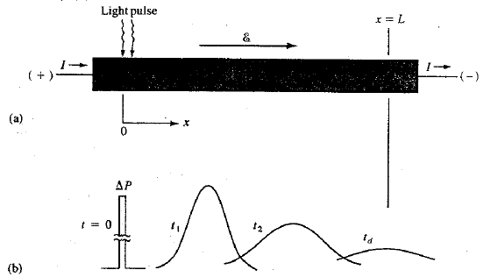
4. The Haynes-Shockley Experiment allows independent measurement of the minority carrier mobility and diffusion coefficient. A pulse of holes is created in an n-type bar that contains an electric field. As the pulse ‘drifts’ in the field and ‘spreads out by diffusion’, the excess hole concentration is monitored at some point of bar. (Fig. 4)
Fig. 4 Fig. 5
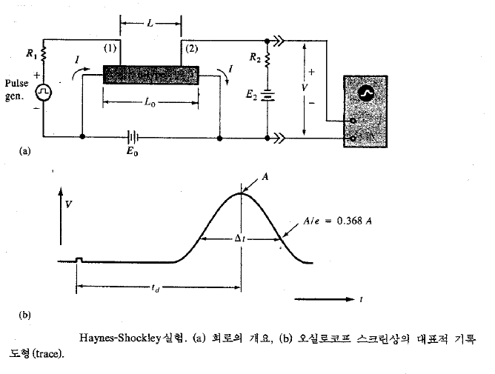
The distribution of holes in the pulse as a function of time can be represented as gaussian distribution; $δp\left(x,t\right)=Ae^{-x^{2}/4D_{p}t}$. (Fig. 5) The schematic of the experiment and typical trace on the oscilloscope screen are presented Fig. 6.
Fig.6

(a) In Fig.6, the length of the sample is 1cm and the probes (1) and (2) are separated by 0.9 cm. The battery voltage E₀ is 1V. A pulse arrives at point (2) 0.9 ms after injection at (1); the width of the pulse Δt is 611us. Calculate the hole mobility and diffusion coefficient. Do the results confirm the Einstein relationship? (Hint: Δt is related to Δx by the drift velocity)
(b) Haynes-Shockley experiment can be used to calculate the hole lifetime in an n-type sample. Let’s assume that the peak voltage of the pulse is proportional to the hole concentration under the collector terminal at time t_{d,} and the displayed pulse can be approximated as a guassian which decays due to recombination by exp(-t/τ_{p}). The electric field is varied and following data taken. For t_{d} = 250us, the peak is 15mV and for t_{d} = 40us, the peak is 120mV. What is τ_{p}?

5. Consider the ideal long silicon pn junction shown in Fig. 7.

Fig. 7

T = 300K, the n-region is doped with 10¹⁶ donor atoms/cm⁻³ and the p-region is doped with 10¹⁷ acceptor atoms/cm⁻³. The minority carrier lifetimes are τ_{n} = 0.05us, τ_{p}= 0.01us. The minority carrier diffusion coefficients are D_{n} = 25 cm²/s and D_{p} = 8 cm²/s. The forward-bias voltage is V_{a}= 0.518V.
(a) Calculate the excess hole concentration as a function of x for x≥0.
(b) Calculate the hole diffusion current density at x = 2 x 10⁻⁴ cm
(c) Calculate the electron current density at x = 2 x 10⁻⁴ cm

