1. semiconductor device mid-term exam solution

Constants:

Ks = 11.8, q = 1.6 x 10-19 C, ε0=8.85 x 10-14 farad/cm, ni = 1010 /cm-3 (T=300K), kT/q = 0.0259V (T=300K)

1. Answer following questions

(a) The lattice constant of Si is 0.543 nm. Using this value, determine the number of Si atoms/cm3.

For Si, 8 atoms are in a unit cell. The lattice constant of Si is 0.543nm.

$$∴\frac{8}{a^{3}}=\frac{8}{({5.43*{10}^{-8}cm)}^{3}}=5.00*{10}^{22}/{cm}^{-3}$$

채점기준) 약간의 오차 허용. 부분점수 없음.

(b) Briefly explain the effective mass. (Fewer than three lines)

결정 구조 내의 캐리어의 움직임을 복잡한 양자역학 공식 대신에 고전역학 공식으로 설명하기 위해 도입한 개념.

(The effective mass is the imported concept to describe the motion of carriers in a crystal with classical mechanical formulation instead of the complex quantum mechanical formulation.)

유사답안) 전자나 정공에 전자기장이 가해졌을 때의 운동을 기술하는데 있어, 자유 전자에 성립하는 물리 법칙을 최대한 이용하기 위해 근사한 질량

채점기준) 주요 키워드를 사용하여 논리적으로 설명했으면 3점. 부분점수 없음.

(c) Explain the reason why Si cannot be used as photoelectric material. Use energy band diagram of Si.

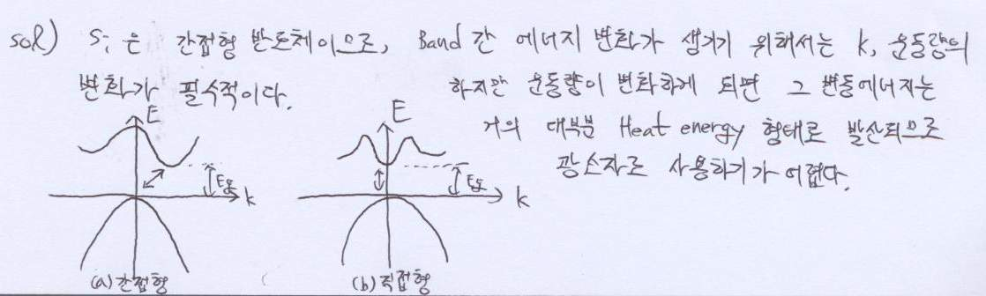

채점기준) 부분점수 있음

간접형 반도체 언급 혹은 E-k 그래프 그림(1점)

** 간접형 반도체임을 언급하였으나 그래프를 잘못 그린 경우 점수 인정 안함

운동량 혹은 phonon 언급(1점)

에너지가 Heat로 쓰이기 때문에 혹은 phonon이 관여한 reaction은 느리기 때문에라고 서술(1점)

*** 세 가지를 모두 언급하여 서술해야 만점

(d) Derive the Einstein Relationship

(Hint: Assume that non-degenerate, non-uniformly doped semiconductor sample is maintaining an equilibrium condition)

Let’s assume non-uniformly doped semiconductor sample is maintaining equilibrium condition. Then net carrier currents become 0. (JN = JP = 0)

For electron,  …(1)

(In this equation,  and ****.)

In equilibrium condition,  and ****.

Then,



** (for electron)**

Similarly, we can derive Einstein relationship for hole.

** (for hole)**

채점기준) (1)번 식 언급하면 1점. 유도 과정이 과하게 생략되었으면 이외 점수 없음.

(e) Explain the meaning of ICB0 and indicate which current component is ICB0 from Fig.1

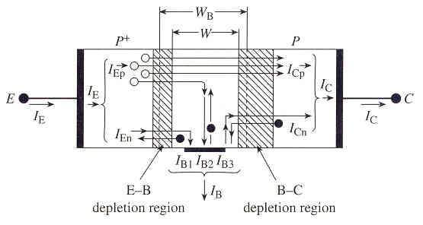ICB0 is minority carrier drift current in P region(collector).

Fig.1

유사정답) Collector current(I_C) that flows when I_E=0 (교과서에 이렇게 나와있음)

채점기준) 부분점수 있음

I_CB0의 의미에 관해 설명(2점)

***모범답안 이외의 표현은 정답으로 인정하지 않음

그림상에서의 indication(즉, I_CB0=I_Cn)(1점)

2. Si sample maintained at 300K is characterized by the energy band diagram in Fig 2.

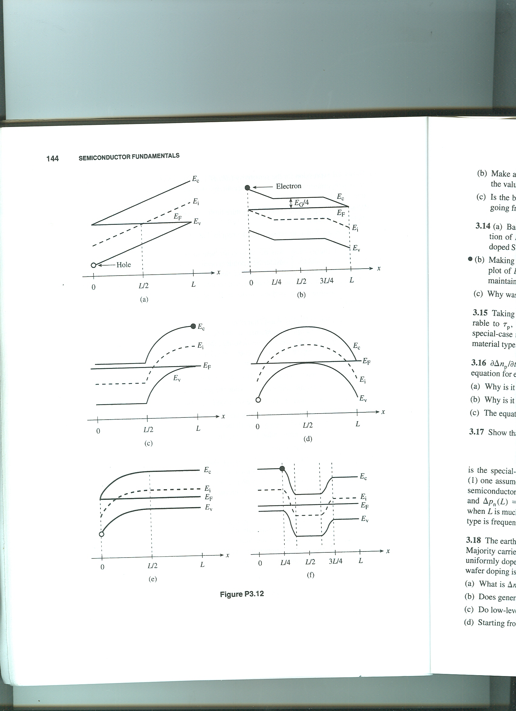This semiconductor is in equilibrium because the Fermi level has the same energy value as a function of position.

Fig. 2

(a) Sketch the electrostatic potential inside the semiconductor as a function of x

- V vs. x has the same functional form as the “upside down” of Ec (or Ei or Ev). The sketches that follow were constructed taking the arbitrary reference voltage to be V = 0 at x = 0.



부분점수 없음

(b) Sketch the electric field inside the semiconductor as a function of x

-  vs. x is determined by simply noting the slope of the energy bands as a function of position.



부분점수 없음

(c) The carrier pictured on the diagram moves back and forth between x = 0 and x = L without changing its total energy. Sketch the K.E. and P.E. of the carrier as a function pf position inside the semiconductor. Let EF be the energy reference level.

- For electrons, P.E. = Ec – EF and K.E. = E – Ec; for holes P.E. = EF – Ev and K.E. = Ev – E.



채점기준) 둘중 하나만 맞았을 경우 1점

(d) Roughly sketch n and p versus x.

- The general carrier concentration variation with position can be deduced by noting EF – Ei vs. x. Under equilibrium conditions,  and  if the semiconductor is non-degenerate.



채점기준) 둘중 하나만 맞았을 경우 1점

그래프가 부분적으로 틀린 경우는 부분점수 없음

직선 slope를 그린 경우 세로축에 log를 표시한 경우만 정답 인정

exponential 곡선 형태를 올바로 그리지 않은 경우는 틀린 것으로 간주

그래프는 그렸는데 n, p를 표시하지 않을 경우 0점

(e) On the same set of coordinates, make a rough sketch of the electron drift-current density and the electron diffusion-current density inside the Si sample as a function of position for given energy band diagram. Be sure to graph the proper polarity of the current densities at all points and clearly identify your two current components.

- The electron drift-current density with position can be deduced by conceptually forming the product of the  vs. x and the n vs. x. Under equilibrium conditions,





채점기준) 둘중 하나만 맞았을 경우 1점

그래프가 부분적으로 틀린 경우는 부분점수 없음

exponential 곡선 형태를 올바로 그리지 않은 경우는 틀린 것으로 간주

그래프는 그렸는데 Current component를 표시하지 않을 경우 0점

3. Two pn junction diodes have the doping profile sketched in Fig. 3

Fig. 3(a) Fig. 3(b)

(a) For Fig. 3(a) and (b), using depletion approximation, derive the charge density solution, electric field solution and electrostatic potential solution. Sketch the expected solutions. What is the equation of the width of depletion region in each case?

(For Fig. 3(b), use depletion approximation as follows; at x=xn, ρ = qND)

(b) For Fig. 3(a), and (b), calculate Vbi, maximum electric field, W, junction capacitance. Assume a Si junction operated at 300K with ND = 4 x 1014/cm-3, NA = 1015 /cm-3, ni = 1010 /cm-3. The cross area of the junction is 2 x 10-3cm2. (Hint: Assume Vbi are same in each case.)

(a) 에서 charge density solution, electric field solution 은 2점, electrostatic potential solution 과 width of depletion region 은 3점. 스케치 당 2점씩. 총 32점. 각 솔루션에서 일부만 맞을 경우 1점. 스케치는 첨부한 모범답안의 notation 들이 빠지면 1점. (단 2차 3차 곡선의 그래프의 경우 솔루션에서 해당하는 식을 유도했다면 2점)

(b) 에서 각 항목당 2점씩. 단 최대 전기장은 3점. 식만 맞으면(쓰면) 1점. 총 18점

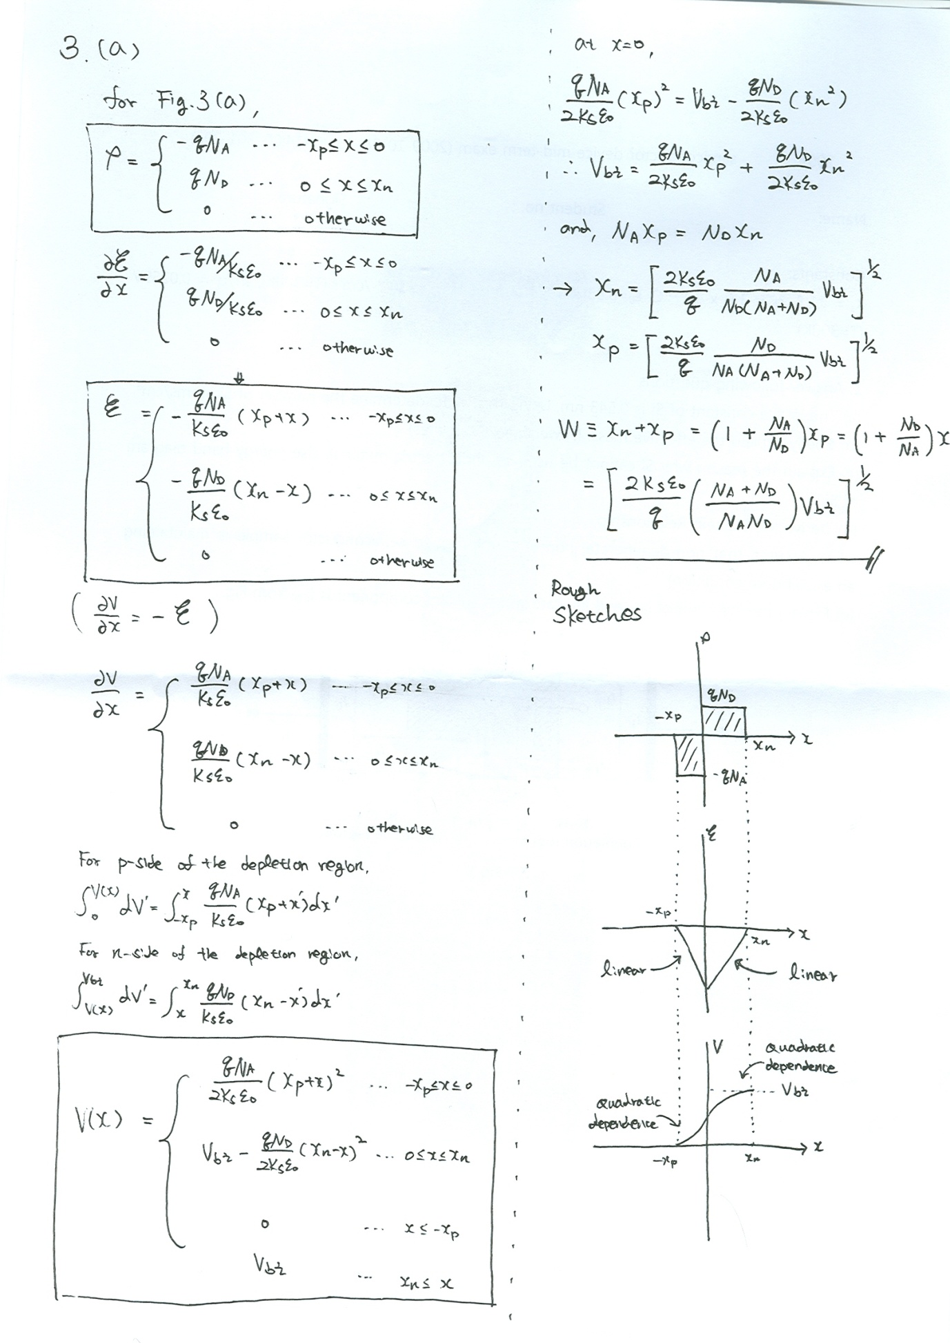

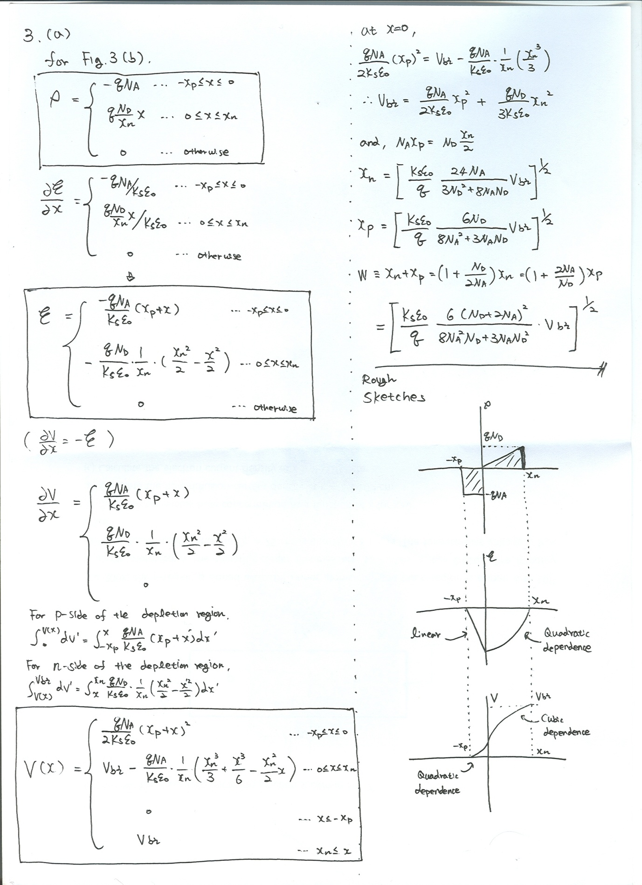

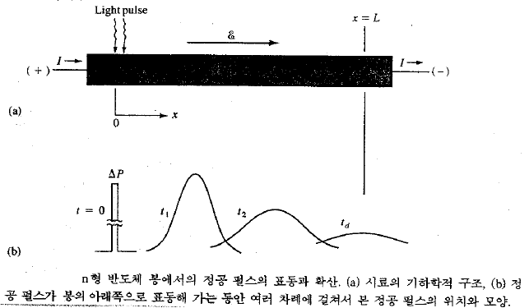4. The Haynes-Shockley Experiment allows independent measurement of the minority carrier mobility and diffusion coefficient. A pulse of holes is created in an n-type bar that contains an electric field. As the pulse ‘drifts’ in the field and ‘spreads out by diffusion’, the excess hole concentration is monitored at some point of bar. (Fig. 4)

Fig. 4 Fig. 5

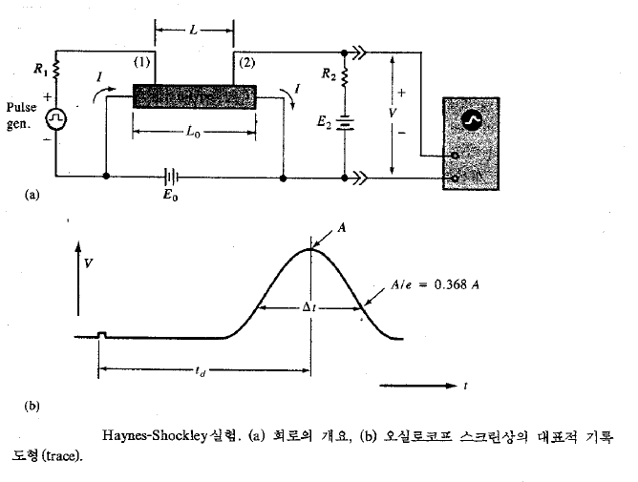The distribution of holes in the pulse as a function of time can be represented as gaussian distribution; $δp\left(x,t\right)=Ae^{-x^{2}/4D_{p}t}$. (Fig. 5) The schematic of the experiment and typical trace on the oscilloscope screen are presented Fig. 6.

Fig.6

(a) In Fig.6, the length of the sample is 1cm and the probes (1) and (2) are separated by 0.9 cm. The battery voltage E0 is 1V. A pulse arrives at point (2) 0.9 ms after injection at (1); the width of the pulse Δt is 611us. Calculate the hole mobility and diffusion coefficient. Do the results confirm the Einstein relationship? (Hint: Δt is related to Δx by the drift velocity)



모빌리티를 정확히 구하면 3점. 일부 식만 적은 경우 1점.



From fig. 5, at x = ,



When , from hint,



여기까지 구하면 8점. 이 부분에서 아인슈타인 관계식 사용시 점수 없음.



The Einstein relationship is confirmed.

여기까지 하면 10점.

(b) Haynes-Shockley experiment can be used to calculate the hole lifetime in an n-type sample. Let’s assume that the peak voltage of the pulse is proportional to the hole concentration under the collector terminal at time td, and the displayed pulse can be approximated as a guassian which decays due to recombination by exp(-t/τp). The electric field is varied and following data taken. For td = 250us, the peak is 15mV and for td = 40us, the peak is 120mV. What is τp?

 and,



(B is constant) -> 이 식, 혹은 관계를 얻으면 3점.



When ->



->



Then,







여기까지의 풀이는 7점.



최종 답까지 정확하게 얻으면 10점

5. Consider the ideal long silicon pn junction shown in Fig. 7.

Fig. 7

T = 300K, the n-region is doped with 1016 donor atoms/cm-3 and the p-region is doped with 1017 acceptor atoms/cm-3. The minority carrier lifetimes are τn = 0.05us, τp= 0.01us. The minority carrier diffusion coefficients are Dn = 25 cm2/s and Dp = 8 cm2/s. The forward-bias voltage is Va= 0.518V.

(a) Calculate the excess hole concentration as a function of x for x≥0.



총 5점 (식 3점 + 답안 2점)

채점기준) 부분점수 있음. 식과 답이 정확히 맞았을 경우 5점.

(b) Calculate the hole diffusion current density at x = 2 x 10-4 cm



총 5점 (식 3점 + 답안 2점)

채점기준) 부분점수 있음. 식과 답이 정확히 맞았을 경우 5점.

(c) Calculate the electron current density at x = 2 x 10-4 cm



총 10점 (Jtot 5점 + Jn 5점)

채점기준) 부분점수 있음. Jtot (식 3점 + 결과 2점 = 5점) + Jn (식, 결과 5점). 식과 답이 정확히 맞았을 경우 10점.