1. semiconductor device final exam

1. ID-VD curve of an n-type MOSFET is plotted as below. Using this device, a simple common source amplifier is constructed as below. (a) What are the gm and gd of the NMOSFET?

(b) Also calculate output impedance, small signal gain and cut-off frequency of this circuit. (Assume no body effect and Cgs and Cgd are both equal to 10pF)

2. A linear device geometry and a rectangular gate of length L by width Z were explicitly assumed in the text derivation of ID-VD relationships. However, MOSFETs have been built with circular geometry as pictured (top view) in Fig. P2.

Fig. P.2

(a) If r1 and r2 are the inside and outside diameters of the gated area, show that in the square-law formulation one obtains

$$I_{D}=\frac{2π}{ln⁡(r_{2}/r_{1})}\overline{μ_{n}}C_{o}\left[\left(V_{G}-V_{T}\right)V_{D}-\frac{V_{D}^{2}}{2}\right]$$

for below pinch-off operation of a MOSFET with circular geometry.

(b) Setting r2 = r1 + L and Z = 2πr1, show that the part (a) result reduces to the linear geometry result, in the limit where L/r1 << 1.

3. (a) In non-ideal MOS, there are oxide charges in the oxide layer, so the value of $V_{T}$ is different with its ideal value. The charge distribution $ρ(x)$ varies in an arbitrary manner across the width of the oxide layer and we can write following equations.

$$\frac{dℇ_{ox}}{dx}=\frac{ρ_{ox}(x)}{K_{o}ε_{o}}$$

$$ℇ_{ox}\left(x\right)=-\frac{{dϕ}_{ox}}{dx}=ℇ_{ox}\left(x_{0}\right)-\frac{1}{K_{o}ε_{o}}\int_{x}^{x_{0}}{ρ_{ox}(x')}dx'$$

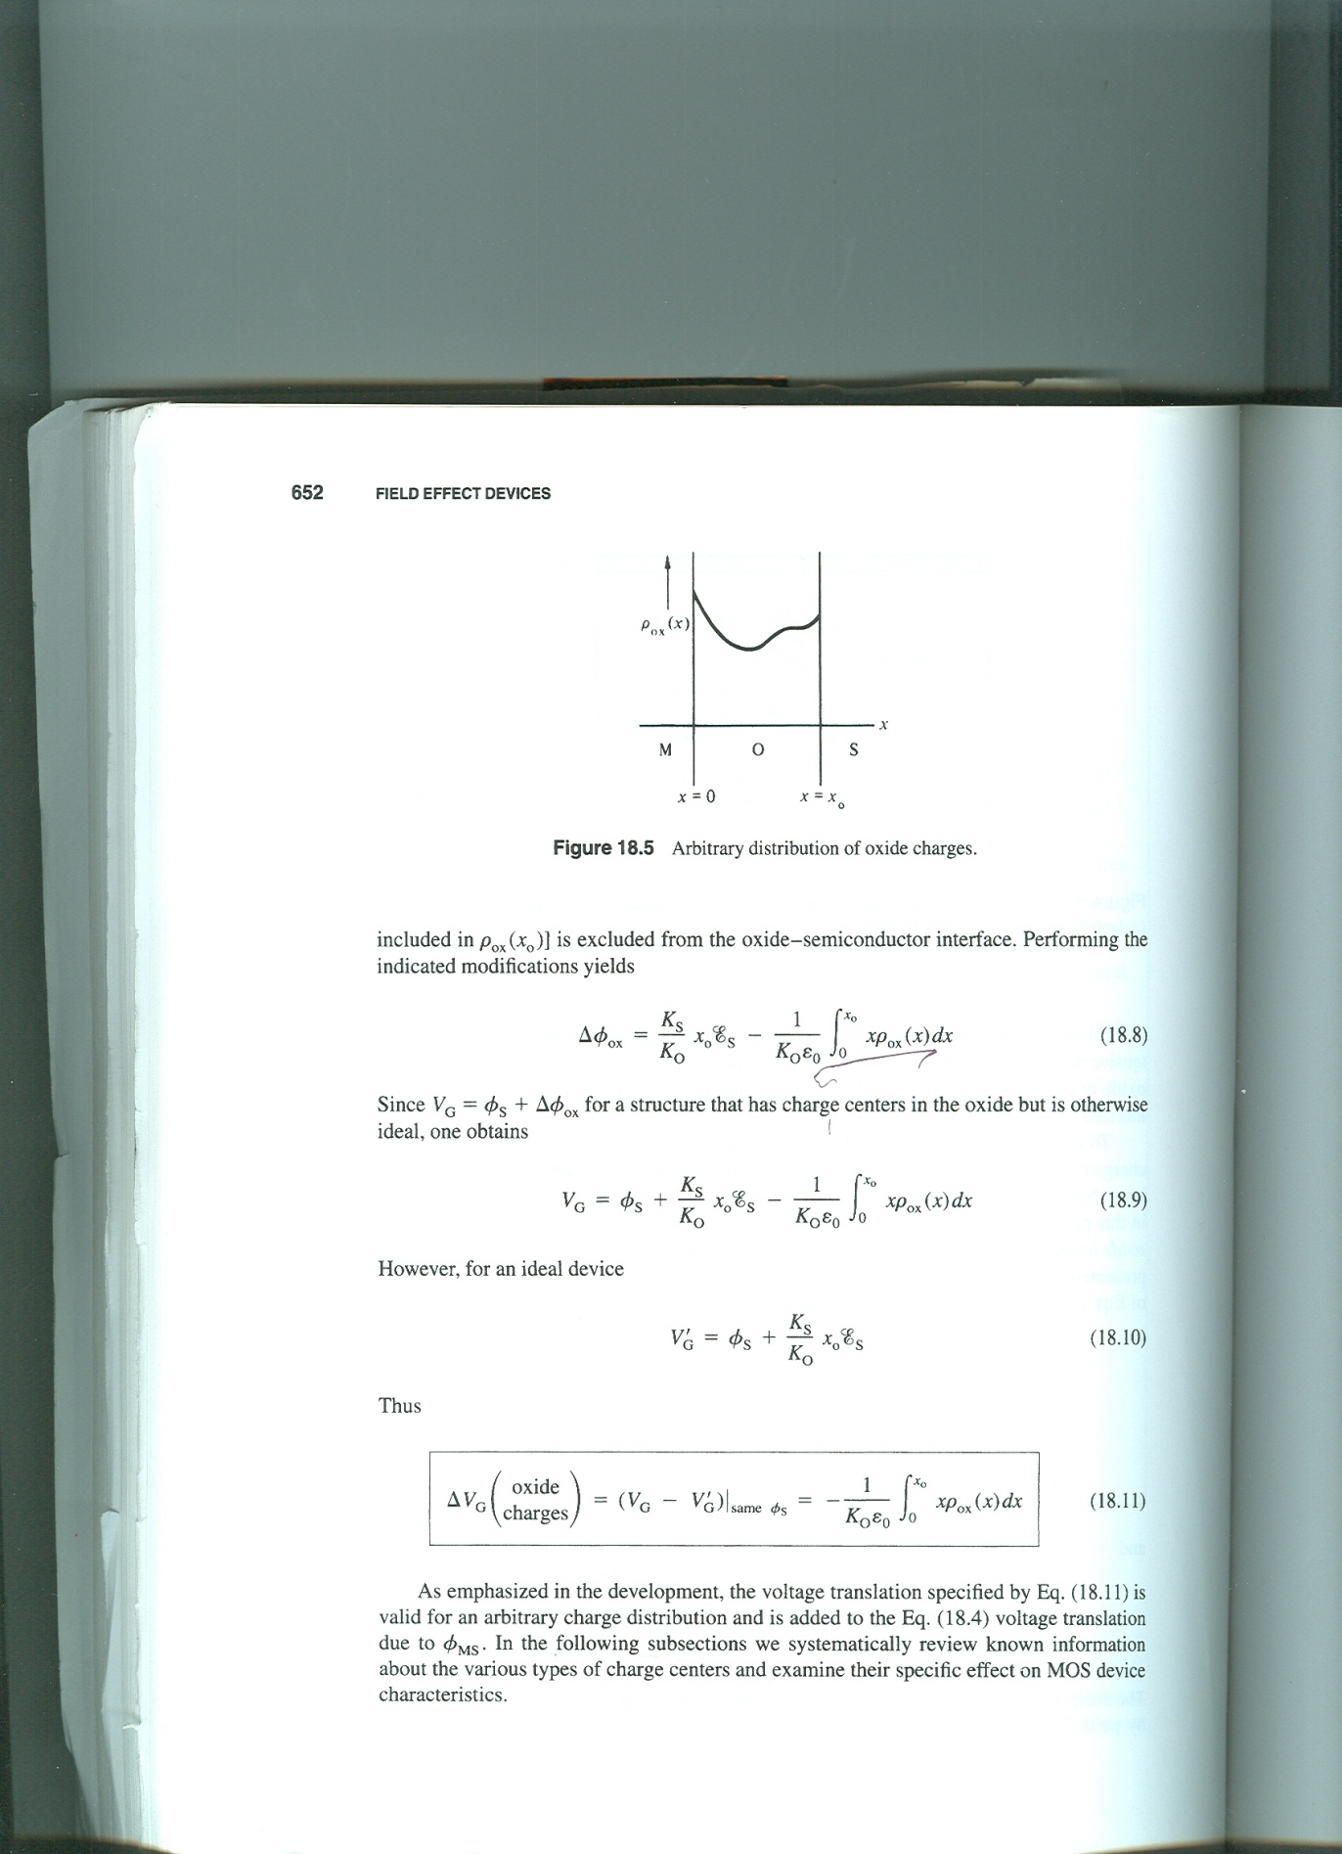Let the origin of the x-coordinate locates at the metal-oxide interface, (fig. P3) derive the expression of $∆V_{T}$ due to the oxide charge shown below.

Fig. P3

(b) Positive bias-temperature(+BT) and negative bias-temperature(-BT) stressing performed for a sufficient amount of time to respectively cause the mobile ions to pile up at the O-S and M-O interfaces, and the voltage displacement between the corresponding C-V curves, are routinely used to deduce the total mobile ion charge/cm2 (QM) inside MOS-Cs.

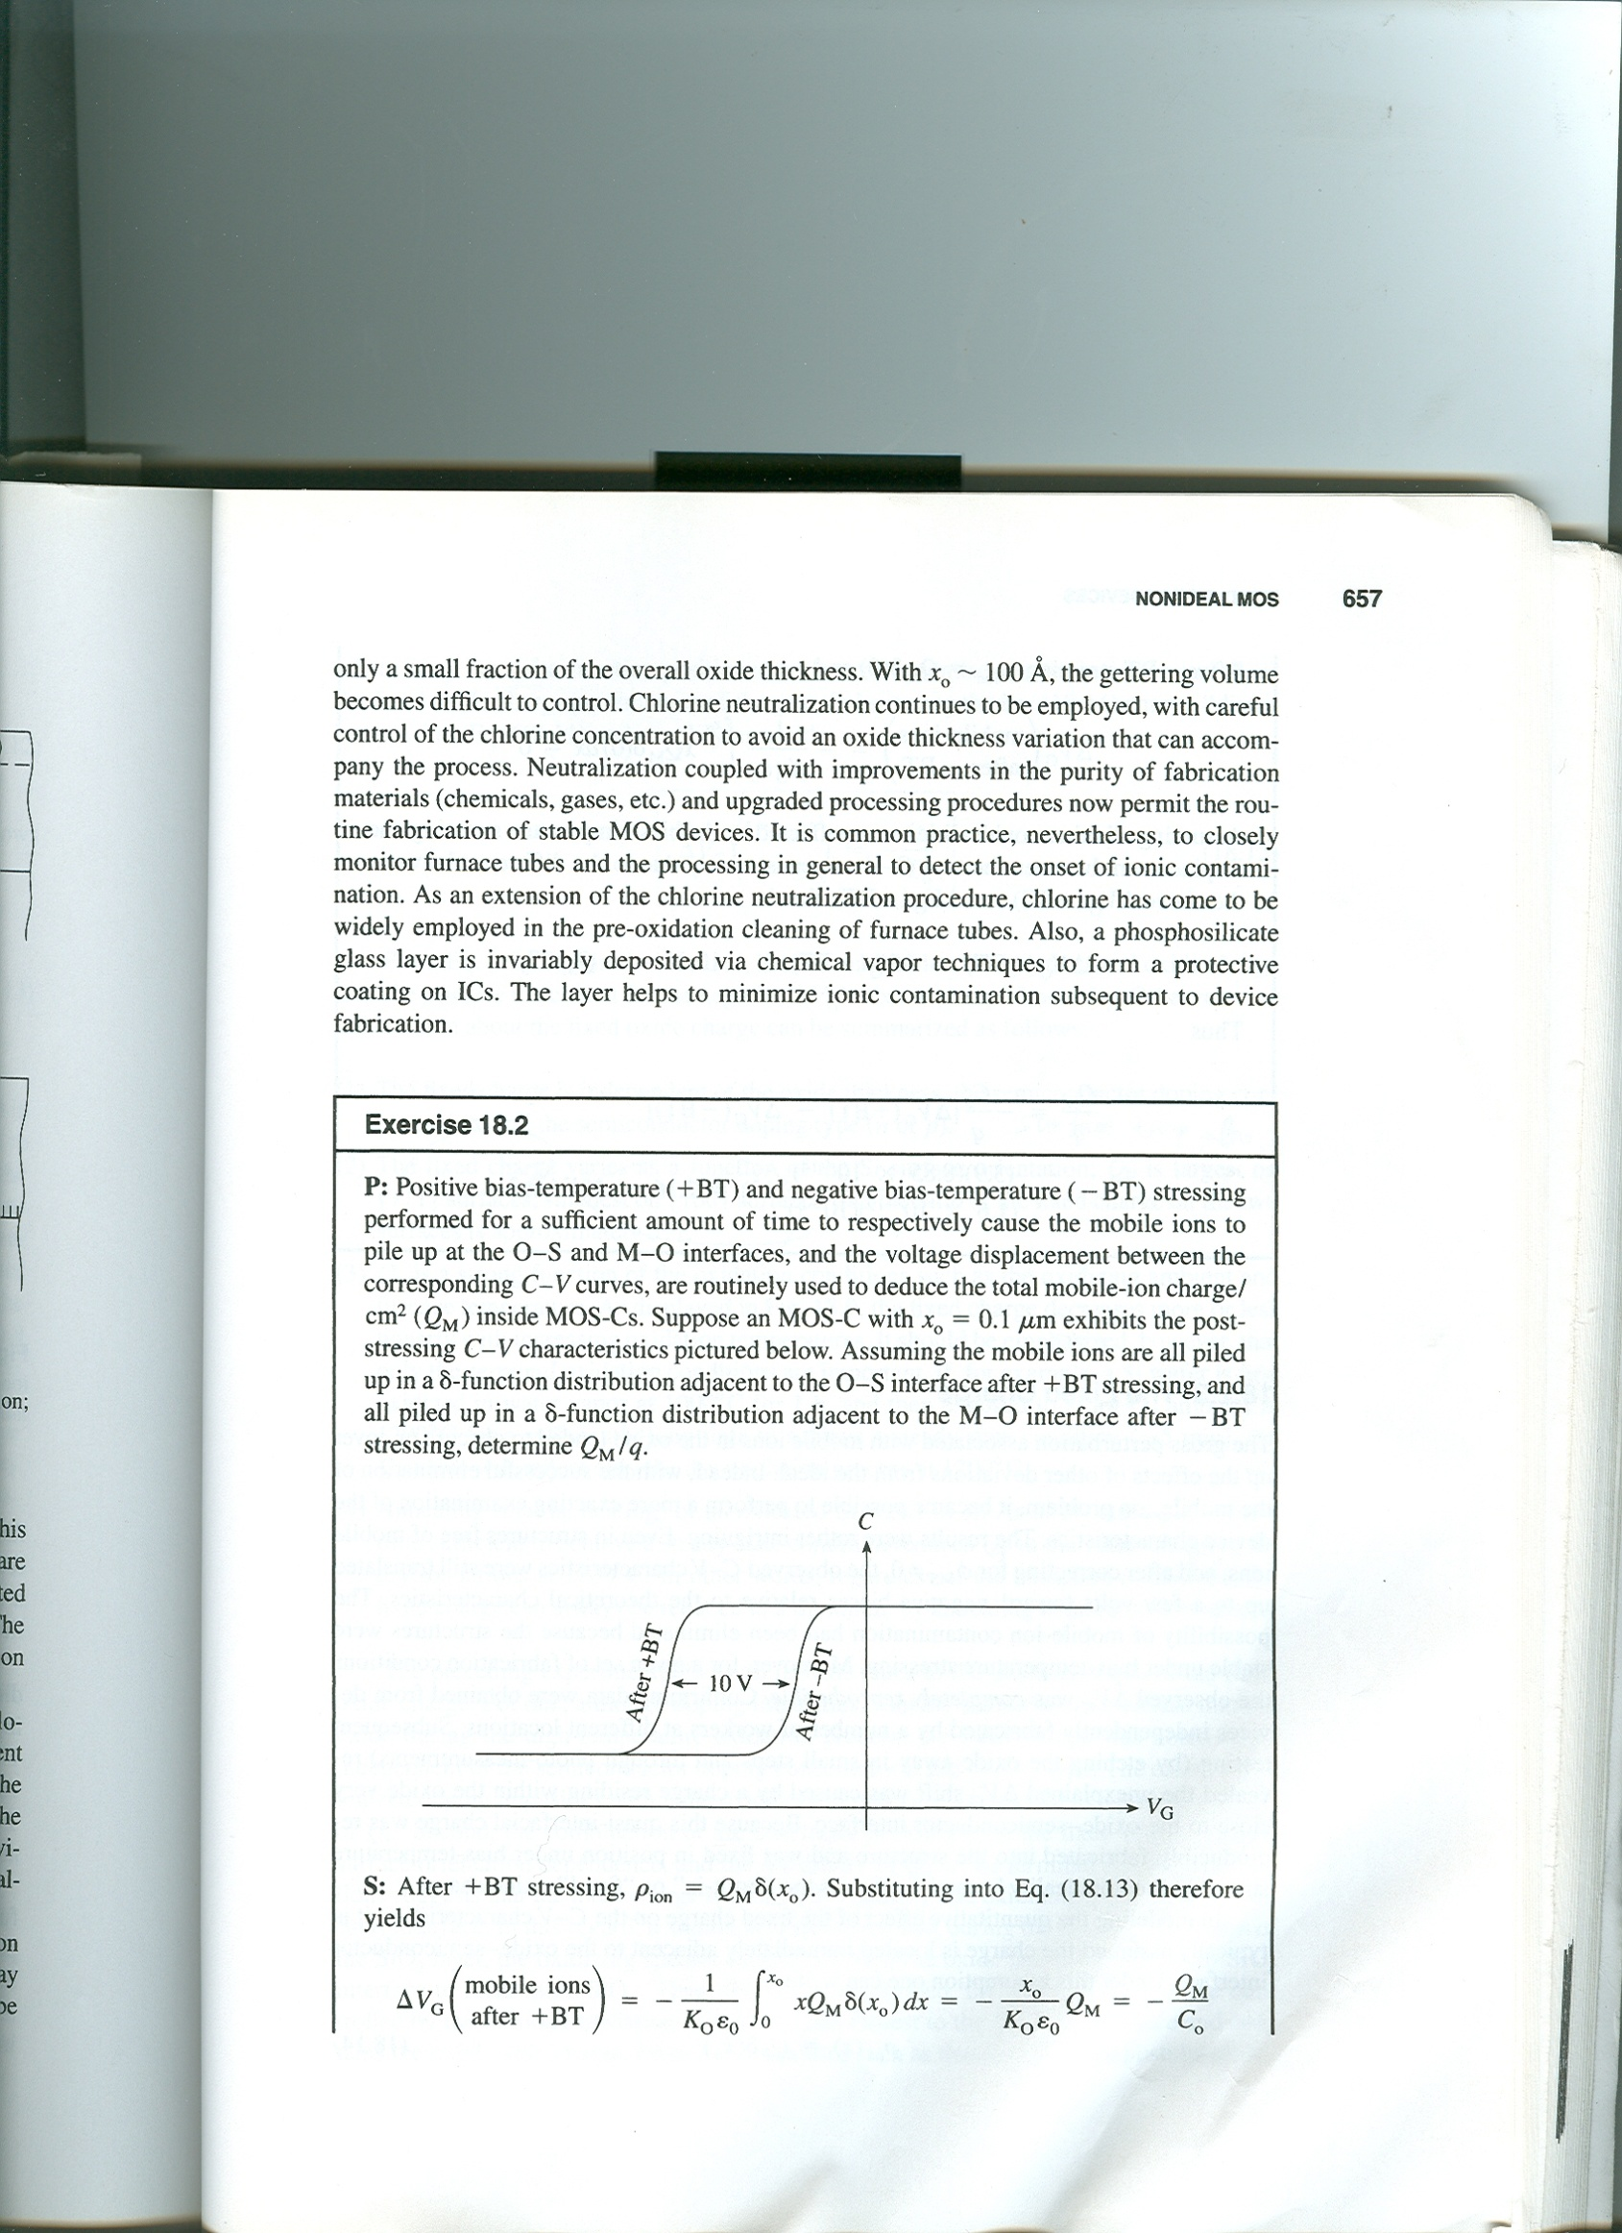Suppose an MOS-C with x0 = 0.1um exhibits the post-stressing C-V characteristics pictured in Fig. P4. Assuming the mobile ions are all piled up in a delta function distribution adjacent to the O-S interface after +BT stressing, and all piled up in a delta function distribution adjacent to the M-O interface after –BT stressing, determine QM/q.

Fig. P4.

4. A p-type MOS structure has following parameters.

ND = 1016 cm-3

oxide thickness = 0.1 um

fixed oxide charge = 







(a) Calculate VT

(b) Ion implantation is the most valuable tool for controlling VT. Using boron ion implantation, we want to reduce VT of (a) to -2V. Calculate the boron ion dose FB (B+ ions/ cm2) to control VT. Assume that the implanted acceptors form a sheet of negative charge just below the Si surface.

(c) If a beam current is 10uA and scanned target area is 500 cm2, what is the implant time?