**항공기 구조역학 중간고사**

일시: 2010년 11월 1일

시간: 15:30 – 16:45

1. Three axially loaded bars, each of length L and all constructed from a material of elasticity modulus ***E***, are arranged as shown in figure. Two bars are connected in parallel and one of these has a cross-sectional area that is twice that of the other. A third bar is connected in series at the common point. An axial load, ***P***, is applied at the junction of the three bars. Using the displacement method, determine (1) the displacement, ***d***, of the connecting point between the three bars and (2) the internal forces in each of the three bars.

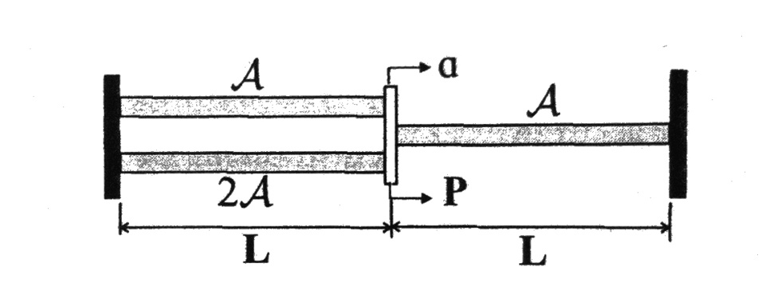

1. The cylindrical bar consists of two segment, clamped at point **R** and **T**, Φ1(**0**)= Φ1(**2L**)=0. The left segment of length **L** is a solid circular bar of radius **R0**, while the right segment of length **L** is a hollow ciruclar bar of inner radius **Ri**, A moment **Q1** is applied at point **M**. (1) Determine the torque carried in each segment. (2) Determine the twist angle at point **M**. (3) Determine the equivalent torsional stiffness, **H**, at point **M**, defined as **H**= Φ1(**L**)/**Q1**. (4) Determine the maximum shear stress in each segment.

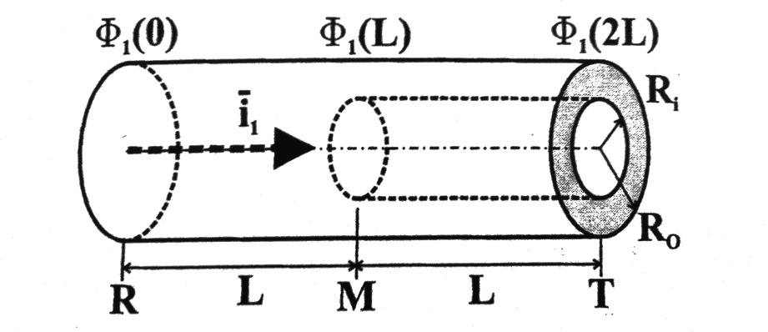

1. A beam with the closed rectangular thin-walled cross-section is subjected to a torque, **Q1**. The walls have differet thickness, as indicated in the figure. (1) Find the magnitude and location of the maximum shear stress in the section. (2) Determine its torsional stiffness.

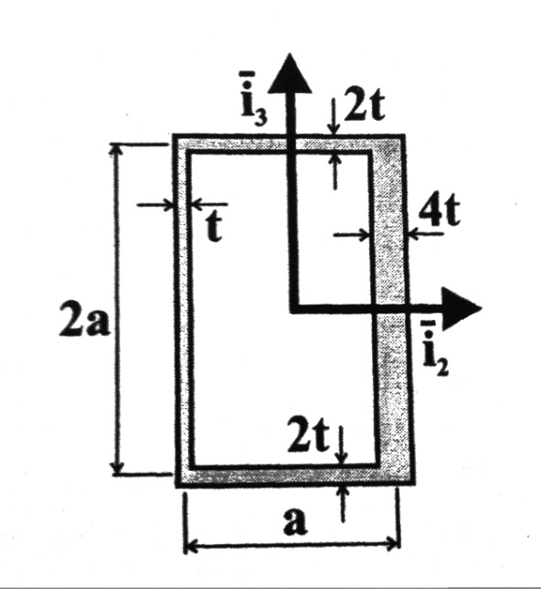

1.

1)

Compatibility

e1=dB; e2=dB; e3=-dB

Constitutive equation

F1=k1e1 ; F2=k2e2; F3=k3e3

Equilibrium at node B

F1+F2-F3-P=0

-P+dBk1+dBk2+dBk3=0



2)



2)



Compatibility

ΦRM=- ΦMT

Strain-displacement

ΦM= ΦRM



Equilibrium = -QRM + Q1 + QMT = 0









3.

1)

Shear flow





2)

